|  |  |
| --- | --- |
|  | **http://upload.wikimedia.org/wikipedia/commons/2/2f/Logo_fpt_university.jpgMINISTRY OF EDUCATION AND TRAINING** |

|  |
| --- |
| **Capstone Project Document**  **SPlace** |
|  |
|  |
| |  |  | | --- | --- | | **S-Team** | | | **Group Members** | Dương Mạnh Tình  Trần Xuân Vương  Đỗ Anh Đức  Uông Quốc Hưng  Võ Anh Tuấn | | **Supervisor** | **Trần Đình Trí** | | **Ext Supervisor** |  | | **Capstone Project code** | SP | |

Table of Contents

1 Introduce 5

1.1 Purpose 5

1.1.1 Project information 5

1.1.2 The peoples 5

1.1.3 Background 6

1.1.4 Reviews of existing systems 6

1.1.5 Our proposal: 7

2 Project Management Plan 8

2.1 Problem Definition 8

2.1.1 Name of this Capstone Project 8

2.1.2 Problem Abstract 8

2.1.3 Project Overview 8

2.2 Project Organization 10

2.2.1 Software Process Model 10

2.2.2 Roles and responsibilities 11

2.2.3 Tools and Techniques 15

2.3 Project Management Plan 15

2.3.1 Task 15

2.3.2 Task sheet: Assignments and Timetable 17

2.3.3 Meeting minutes 18

2.4 Communication Plan 24

2.4.1 Internal project communication 24

2.4.2 Communication with Supervisor 24

2.4.3 Risk 24

2.4.4 Java coding convention 25

Identifier Type 25

Rules for Naming 25

3 System Requirements Specifications 26

3.1 User Requirement Specification 26

3.2 System Requirement Specification 27

3.2.1 User Interfaces 27

3.2.2 Functional Requirements 29

3.3 Entity Relationship Diagram or Data Structures 61

4 Software Design Description 62

4.1 Design Overview 62

4.2 System Architectural Design 63

4.2.1 Choice of System Architecture 63

4.2.2 Discussion of Alternative Designs 64

4.2.3 Description of System Interface 66

4.3 Component Diagram 66

4.4 Detailed Description of Components 66

4.4.1 CRC Cards (Class-Responsibility-Collaborators) 66

4.4.2 Class Diagram 72

4.4.3 Flow-Chart 72

4.5 Sequence Diagram 79

4.5.1 Login 79

4.5.2 Add Place 80

4.5.3 Comment 81

4.5.4 Search 82

4.5.5 Get Direction 82

4.5.6 Review Place 83

4.6 User Interface Design / Hardware Interface Design 84

4.6.1 Sign Up & Sign In 84

4.6.2 List Place By category 85

4.6.3 List Category 86

4.6.4 Get Direction 87

4.6.5 Search Screen 89

4.6.6 Add new place 90

4.6.7 Search result on Map 91

4.6.8 Information of Place 92

4.6.9 List Place Images 93

4.6.10 Edit user information 94

4.7 Database Design 95

5 System Implementation & Test (SIT) 95

5.1 Introduction 95

5.1.1 Overview 95

5.1.2 Test Approach 96

5.2 Test plan 98

5.2.1 Features to be tested 98

5.2.2 Feature not to be tested 99

5.2.3 Testing tools and environment 99

5.3 Test Case 99

5.3.1 Unit Test 100

5.3.2 Integration Test 104

5.3.3 System test 127

5.3.4 Acceptance testing 148

5.4 Checklists 148

5.4.1 Checklist of validation : 148

5.4.2 Submission checklist 149

6 System User’s Manual 151

6.1 Installation Guide 151

6.1.1 Application’s environmental require 151

6.1.2 Installing into Device 151

6.2 User Guide 151

6.2.1 Login/Register/Forgot Password Guide 151

6.2.2 Application Guide 154

6.3 Reference 165

|  |
| --- |
|  |

# Introduce

## Purpose

This document descripts overview about the capstone project. This will introduce about team members, background and proposal of this capstone project.

This project is registered and implemented as the capstone project for the team members. The first purpose is to fulfill the requirements from FPT University studying program. The second purpose is to create a complete product for going live and expand in the future.

### Project information

* Project Name : SPlace
* Project Code : SP
* Product Type : Android Application (Front -End client) & Website Application (Back-End)
* Timeline :

### The peoples

Supervisors

|  |  |  |  |  |
| --- | --- | --- | --- | --- |
|  | Full Name | Email | Phone | Title |
| Supervisors 1 | Trần Đình Trí | [tritd@fpt.edu.vn](mailto:tritd@fpt.edu.vn) | 0913091952 | Lecturer |

Team members

|  |  |  |  |  |  |
| --- | --- | --- | --- | --- | --- |
|  | Full Name | Student Code | Email | Phone | Role in group |
|  | Trần Xuân Vương | 60586 | [Vuongtx60586@fpt.edu.vn](mailto:Vuongtx60586@fpt.edu.vn) | 0986599959 |  |
|  | Dương Mạnh Tình | 00896 | [Tinhdm00896@fpt.edu.vn](mailto:Tinhdm00896@fpt.edu.vn) | 0932300090 |  |
|  | Võ Anh Tuấn | 01312 | [Tuanva01312@fpt.edu.vn](mailto:Tuanva01312@fpt.edu.vn) | 0973732360 |  |
|  | Đỗ Anh Đức | 00970 | [Ducda00970@fpt.edu.vn](mailto:Ducda00970@fpt.edu.vn) | 01689967122 |  |
|  | Uông Quốc Hưng | 01629 | [Hunguq01629@fpt.edu.vn](mailto:Hunguq01629@fpt.edu.vn) | 01682305618 |  |

### Background

Now, people spend a lot of time for searching, asking friend to know where are the places for shopping, eating, drinking… that meet their needs.

Of course they can do that with some service just like Google maps, Diachiso…, but these service only provide some limited informations about address, description images, they do not provide users the quality, the feedback about place of other users and the rating also.

It is better if we have an application that we can use to search for places, and also can see feedbacks, comments from these others. Then, we can decide which is the best place that meet our criterias. Of course we can also share our comments about places to these other.

For these reason, we are going to provide such services. We plan to build an application that allows peoples to find places, get direction to places, share their knowledges about places, they can also comment & rate a place to make informations about that place and let others know about these informations. They can also connect easily with their social account & share their activities on social networks accounts.

Because the smartphone is very popular now, so we think that the phone application is more suitable than the website application.

### Reviews of existing systems

|  |  |  |  |
| --- | --- | --- | --- |
|  | Descriptions | Strength | Weakness |
| Google Place | -Focus on Business Owner - Allow business owner to add, update information about owned business | - Information is up-to-date  - Provide additional detail like photos, working time, coupons… | - have only website version  - Not fully support in Vietnam. |
| Foursquare | -a sharing location social network, where users can check-in at nearby place | - Provide good interface, allow users to find feedbacks, reviews & tips about place  - Application work well on smartphone. | - Not fully support in Vietnam  - Do not have the direction function. |
| Place.vn | -a place-sharing network of Vietnam. | - These are a lot of information about place: address, images, descriptions, reviews, comments.  -Have sorting features by rating of users  -Users can share their feedbacks about place | -have only website version. |
| Diachiso.vn | -a Place directory website of Vietnam | - Provide information about place, have a big number of place data.  - also have location base map | - Have only website version  -Data is out-of-date. |

### Our proposal:

To solve the demand of searching for place, needing to know about the quality of place, sharing feedback & rating about place, get direction to place and friendly user-interface, we plan to develop an smartphone application to serve end-users ( front-end ), and a website application to work with staff ( back-end )

This project, called S-place, will have some kind of tasks:

* Allow users to search, find a place in specified area or place around, or search by name, by category.
* Allow users to comment, rate, give feedback about place.
* Allow users to add more content (place), or suggest edit information about place ( these content will be reviewed and approved before published )
* Determine the current location of users.
* Find the shortest way from one location to another.
* Allow Staff to review and approve place before publisher.

# Project Management Plan



## **Problem Definition**

### Name of this Capstone Project

The official and formal name of this project is S-Place. The project aim to 2 main purposes: building a well interactive front-end android app for searching and sharing information of location in Viet Nam(travel, restaurant, movie, market, education). And a standard back-end for managing information of places and configuration for user account

### Problem Abstract

The purpose of this project is creating an application where users can find best places for their purpose and share the place to their friends.

Currently, there are some other products providing the same services, but each of them also has their own advantages and disadvantages. We intend to create a new product that combine all advantages and minimize all disadvantage of those products.

When completed, the product should obtain the following features:

- Running as a sharing network where most of the place's data are recommended by user and managed by admin.

- Having a good initial database for many kinds of places.

- User-friendly

- Having a good rating system that makes the places most reliable.

### Project Overview

#### The Current System

There is no current system. The our product is building from new idea.

#### The proposed system

**Define usergroup**

There are three kind of user: Admin, user, guest.

**Over view**

**Our Purpose**To solve the demand of searching for place, needing to know about the quality of place, sharing feedback & rating about place, get direction to place and friendly user-interface, we plan to develop an smartphone application to serve end-users ( front-end ), and a website application to work with staff ( back-end )

This project, called S-place, will have some tasks :

* Allow users to add more content (place), or suggest edit information about place ( these content will be reviewed and approved before published )
* Allow Staff to review and approve place before publisher.
* Allow users to comment, rate, give feedback about place.
* Determine the current location of users.
* Allow users to search, find a place in specified area or place around, or search by name, by category.
* Find the shortest way from one location to another.

**Task for each role**

The system will provide the following main features in frond-end:

- User can use application then search for some kinds of place

- User can recommend places to the app

- User can rate and comment places.

The back-end will allow the administrators to manage places, user, review recommend place, system configuration..

#### Boundaries of the system

The system under development of this Capstone Project will include:

- The complete android application

- A web service

- All the process documents involved

#### Development Environment

The following list of software requirement needed for develop:

- Operating system: windows 7, windows 8, Ubuntu 12.04

- Java Development Kit 7

- Android SDK 22.2.1

- Android device 4.3

- PHP – Laravel 4

- Sublime text 2

- Mysql 5.6

- Android Developer Tools Build: v22.2.1-833290

## Project Organization

### Software Process Model

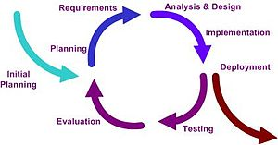

Figure 2‑1 : Iterative Process Model

The process model used for developing this project is iterative because

+ Integration and testing is executed continuously, so the workload of the members in team is spread out more evenly throughout the lifecycle.

+ Prevent undetected misunderstanding by user feedback in each iteration. It is possible to make soon reacting and minimize the damage.

+ In every iteration, there is always something runnable as concrete evidences of the project's status

+ The team members can leverage lessons learned more effectively and therefore can improve the process and quality of project

### Roles and responsibilities

|  |  |  |
| --- | --- | --- |
| Name of role | Brief Description of Responsibilities | Responsibilities |
| Project manager  (PM) | -Responsible for developing, in conjunction with the Project Sponsor, a definition of the project. The Project Manager then ensures that the project is delivered on time, to budget and to the required quality standard (within agreed specifications). He/she ensures the project is effectively resourced and manages relationships with a wide range of groups (including all project contributors). The project Manager is also responsible for managing the work consultants, allocating and utilizing resources in an efficient manner and maintaining a co-operative, motivated and successful team. | Managing and leading the project team.  Managing co-ordination of the partners and working groups engaged in project work.  Detailed project planning and control including:  Developing and maintaining a detailed project plan.  Managing project deliverables in line with the project plan.  Recording and managing project issues and escalating where necessary.  Resolving cross-functional issues at project level.  Managing project scope and change control and escalating issues where necessary.  Monitoring project progress and performance.  Providing status reports to the project evaluation and dissemination activities.  Final approval of the design specification.  Working closely with users to ensure the project meets business needs.  Definition and management of the User Acceptance Testing program  Identifying user training needs and devising and managing user training programs |
| The Analysis | -The analyst is responsible for ensuring that the requirements of the business clients are captured and documented correctly before a solution is developed and implemented. In some companies, this person might be called a Business Analyst, Business Systems Analyst, Systems Analyst or a Requirements Analyst | Analyzing and understanding the current state processes to ensure that the context and implications of change are understood by the clients and the project team.  Developing an understanding of how present and future business needs will impact the solution  Identifying the sources of requirements and understanding how roles help determine the relative validity of requirements.  Developing a Requirements management Plan and disseminating the plan to all stakeholders.  Identifying and documenting all business, technical, product and process requirements.  Working with the client to prioritize and rationalize the requirements.  Helping to define acceptance criteria for completion of the solution |
| QA | Responsible for applying the principles and practices of software  Quality assurance throughout the system lifecycle. Through testing, analyst, and observation, a person in this position not only ensures that requirements and standards have been…. | To operate effective QA procedures  To provide guidance and support to facilitate the fair operation of the system.  To promote inclusive approach and ensure compliance under existing policy legislation.  To maintain creditability of awards |
| Project team members | The staff who actively work on the project, at some stage, during the lifetime of the project. Some may have a specific roles | Provide functional expertise in an administrative process  Work with users to ensure the project meets business needs  Documentation and analysis of current and future processes/systems  Identification and mapping of information needs  Defining requirements for reporting and interfacing  User training |
| Designer | The Designer is responsible for understanding the business requirements and designing a solution that will meet the business needs. There are many potential solutions that will meet the client’s needs. The designer determines the best approach. A designer typically needs to understand how technology can be used to create this optimum solution for the client. The designer determines the overall model and framework for the solution, down to the level of designing screen, report, program and other components. They also determine the data needs. The work of the designer is then handed off to the programmers and other people who will construct the solution based on the design specifications. | Have a basic understanding of technology in order to know what is or is not possible given certain technology realities. Quickly and accurately recognize performance/knowledge gaps.  Creativity tempered with an understanding of the intended audience, client culture, and learning preferences.  Understanding of human computer factors and interface design.  Ability and willingness to a adapt to a dynamic set of standards and tools. |
| Developer | The developer is the organization designated as the lead agency on the development of the project. The developer is ultimately responsible, whether through in-house staff or through engaging the services of a development consultant for managing the development team and driving the development process from the units. In many cases, the develop will continue to own the project after it is completed and operational. | An analytical, methodical approach to work.  Ingenuity around creation of reusable objects and engines.  Ability to code optimally and choose the right tool based on the technologies available to the audience. |
| Tester | Testers need to identify the critical issues with the system as soon as possible and make sure that the information supplied is sufficient to reproduce the ussue. We need to supply the information on the presence of bugs in the system to the stake holders. The information should help the stake holders to take informed decisions. | Design and document test cases, execute test cases, record test case results, document and track defects, and perform test coverage analysis.  In this capstone project, Testers will do Function test and System test.  The test designer creates test cases that test at the level of distinct business events or functional process.  The test designer creates test cases that test at the level of the system or complete end-to-end business threads. |
| Document maintainer | Responsible for writing documents (gathering information, writing reports and project documentation). Has a responsibility for preparing a document for review, making review changes, updating the document version number. |  |

In this project, we assign Role and Responsibility as follow:

|  |  |
| --- | --- |
| Full Name | Role |
| TRẦN XUÂN VƯƠNG | Developer  Designer  Tester |
| ĐỖ ANH ĐỨC | Developer  Designer  Tester |
| UÔNG QUỐC HƯNG | Document Maintainer  Business Analyst  Tester |
| VÕ ANH TUẤN | Project technical leader  Developer  Designer |
| DƯƠNG MẠNH TÌNH | Document Maintainer  Business Analyst  Tester |

### Tools and Techniques

The following list of software requirement needed for develop:

- Operating system: windows 7, windows 8, Ubuntu 12.04

- Java Development Kit 7

- Android SDK 22.2.1

- Android device 4.3

- PHP – Laravel 4

- Sublime text 2

- Mysql 5.6

- Android Developer Tools Build: v22.2.1-833290

- Apache Httpd Version 2

- MySQL Workbench 6.0.7

- phpMyADMIN

## Project Management Plan

### Task

|  |  |  |  |  |  |  |
| --- | --- | --- | --- | --- | --- | --- |
| **No** | **Task Name** | **Description** | **Deliverables** | **Resources Needed** | **Dependencies / constraints** | **Risk** |
| **Initiatling** | | | | | | |
| 1 | Project Kick-off | Define roles member and create plan for project. | Project charter |  |  |  |
| **Planning** | | | | | | |
| 2 | Project plan | Create Project Plan. | Project Schedule |  |  |  |
| **Excuting** | | | | | | |
| 3 | Android and PHP Training | Training Android and PHP for team. | Pilot Project |  |  |  |
| 4 | Requirements Defining | Eliciting, defining and documenting user requirements for VEIP system. | SR document |  |  |  |
| 5 | Create System Test | Developing test plan and system test cases. | System test plan  System test cases | SR document |  |  |
| 6 | Designing | Developing software detailed design for system. | SAD document  SDD document | SR document |  |  |
| 7 | Coding | Setup coding environment, create GUI design and coding. | Coding Package  SUM document | SAD document |  |  |
| 8 | Testing | Executing system test case. | STD document |  |  |  |
| 9 | Deployment | Deploy product to server and app store. |  |  |  |  |
| **Closing Project** | | | | | | |
| 10 | Closing Project | Closing project and prepare final presentation. | Lesson learned document |  |  |  |

### 

### Task sheet: Assignments and Timetable

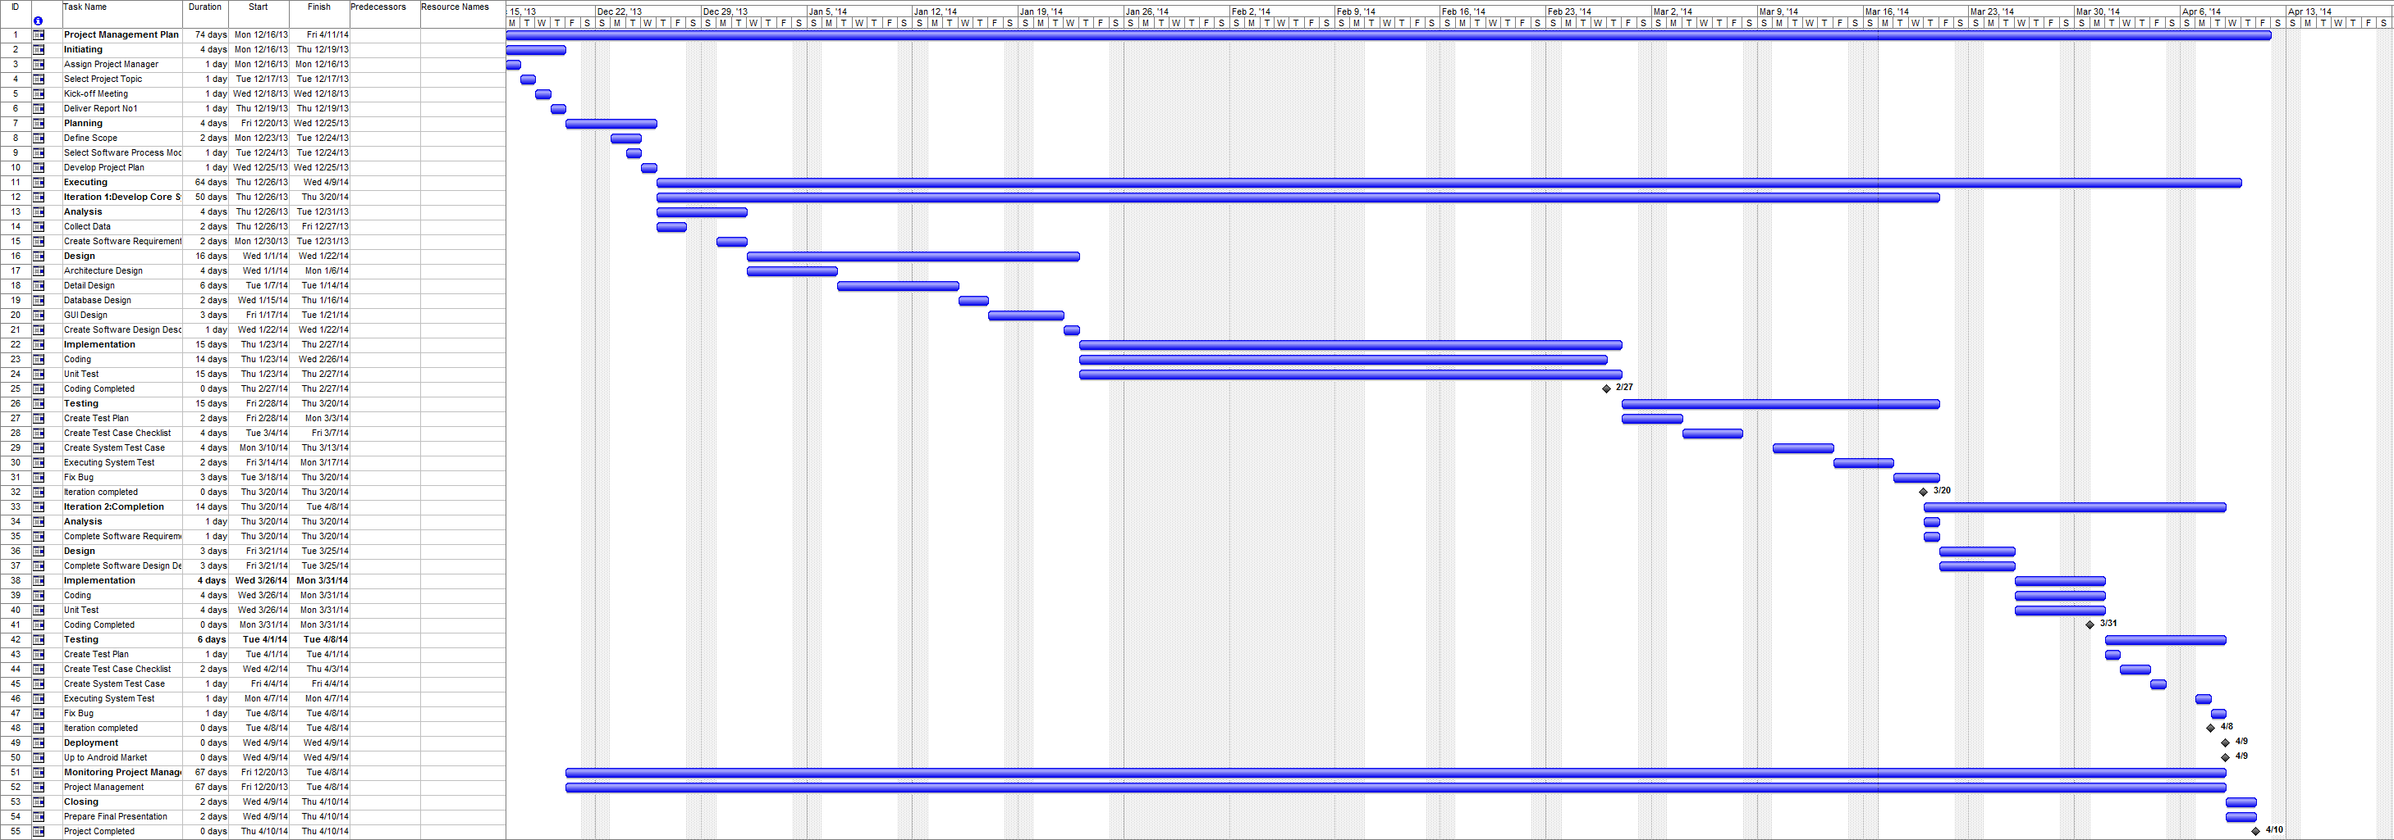

Figure 2‑2 : Project Plan

### Meeting minutes

Initialization Project

|  |  |  |  |  |  |  |  |  |
| --- | --- | --- | --- | --- | --- | --- | --- | --- |
| **Meeting Information** | | | | | | | | |
| **Description** | | | S-Place Project Initiation Meeting No.1 | | | | | |
| **Date** | | | 12/16/2013 | | **Time** | | 3:00pm – 5:00pm | |
| **Facilitator** | | |  | | **Scribe** | | TriTD | |
| **Objective** | | | Determining capstone project and first building-up team | | | | | |
| **Attendees** | | | Supervisor: Mr. TRAN DINH TRI | | | | | |
| Team members:   * VuongTX * TuanVA * TinhDM * DucDA * HungUQ | | | | | |
| **Key Points Discussed** | | | | | | | | |
| **No** | **Topic** | | | **Highlights** | | | | |
| 1 | Collecting and discussing about ideas of possible capstone projects | | | Possible projects:   * S-Place: An Android application support find special place. * Game Đánh bài on Android device | | | | |
| 2 | Debating among team and selecting best project for implementing | | | Selected project: S-Place | | | | |
| 3 | Selecting group name | | | Agreed group name: S-Team | | | | |
| 4 | Selecting project name | | | Agreed project name: S-Place | | | | |
| 5 | Assigning roles and responsibilities for team members | | | **List of commissions:**   * Project manager: VuongTX * Project technique leader: TuanVA * Developer: VuongTX,TuanVA,DucDA * Test leader:TinhDM * Tester: TinhDM, HungUQ * Quality assurance: TinhDM,HungUQ * Configuration manager: VuongTX | | | | |
| 6 | Discussing about plans for developing ideas and taking more requirements for selected project | | | * The introduction document and report for overall advantages (include benefits) as well as disadvantages of S-Place system should be done to get all members’ recognition and comprehending * The researching and analysing of all existing application in both Vietnam and foreign countries must be done carefully | | | | |
| 7 | Define the communication channels that members must be available to contact | | | * Agreed channels: * Face-to-face contact and group’s daily meeting on morning (9:00am-13:00pm). * Facebook and Skype (online conference) * Gmail * Mobile phone | | | | |
| 8 | Creating some important work rules for all team | | | Attendance and Punctuality rules:   * Every member has to attend in informed or scheduled meetings (or conferences) in time. * Every member has to finish assigned tasks with acceptable quality and in time * The financial punishments is for any absence or lateness (that is not informed to project manager or leaders before deadlines an acceptable amount of time) * Replying and feedback rules: * The member who needs reply or feedback from others in team must inform clearly through mail * Any issue must be replied within 24 hours max | | | | |
| **Action Plan** | | | | | | | | |
| **No** | | **Action Item** | | | | **Owner** | | **Target Date** |
| 1 | | Setting-up next meeting | | | | All teams | | 17/18/2013 |
| 2 | | Creating basic introduction document and presentation ideas of S-Place system to all members in next meeting | | | | VuongTX | | 17/18/2013 |
| 3 | | Creating research report of current place finder application | | | | TinhDM | | 17/18/2013 |
| 4 | | Designing surveys and creating interviewing plan to elicit user requirements of S-Place system | | | | TuanVA | | 17/18/2013 |

|  |  |  |  |  |  |  |  |  |  |
| --- | --- | --- | --- | --- | --- | --- | --- | --- | --- |
| **Meeting Information** | | | | | | | | | |
| **Description** | | | | S-Place Project Initiation Meeting No.2 | | | | | |
| **Date** | | | | 12/17/2013 | | **Time** | | 9:00am – 11:00am | |
| **Facilitator** | | | |  | | **Scribe** | | VuongTX | |
| **Objective** | | | | Determining purpose, scope of project and development environment | | | | | |
| **Attendees** | | | | Supervisor: Mr. TRẦN ĐÌNH TRÍ | | | | | |
| Team members:   * VuongTX (Project Manager, Developer) * TuanVA (Technical Leader, Developer) * DucDA (Developer) * HungUQ (QA, Tester) * TinhDM (Test Leader, QA) | | | | | |
| **Key Points Discussed** | | | | | | | | |
| **No** | **Topic** | | | **Highlights** | | | | |
| 1 | Presenting purpose and basic ideas of S-Place project | | | * Purpose of system: Create an Android application that user can share, search place for their purpose * Main ideas: * The main objects provide place information (tips, overview) for user. * The main supported user: everyone to find place. | | | | |
| 2 | Discussing about existing systems | | | * Advantages and disadvantages of these system. * Lessons learned from these system: * The need to focus on users (habits, user’s interests) to give best suggestion. * The need to have an sharing place application in Vietnam | | | | |
| 3 | Brain-storming more ideas for S-Place system | | | The list of information categories of location: travel, education,restaurants, hotels.. that user may desire  The list of possible functions and the focused ones.  Trending function is the heart of this application. | | | | |
| 4 | Defining the scope of developed system and work in capstone project | | | The scope of final product of capstone project- S-Place system:   * S-Place application on Android and back-end website * Other environments like IOS or Window Phone will be extended later. * Required documents of capstone project has to be done paralleled and submitted in specific deadline | | | | |
| 5 | Determining developing process for project | | | Agreed model: interactive model | | | | |
| 6 | Determining required tools and techniques in project (**in** **conjecture**) | | | Some available techniques source:   * Android 4.3 * PHP 5 and later, MySQL | | | | |
| 7 | Defining some required research or training in project | | | The research of business and functions of sharing networking.  About technique, the research of PHP framework for server.  The training and self-retraining of Android and PHP should be performed among team (the level depends on the degree that member is close to project development) | | | | |
| **Action Plan** | | | | | | | | |
| **No** | | **Action Item** | | | | **Owner** | | **Target Date** |
| 1 | | Setting-up next meeting | | | | All teams | | 12/17/2013 |
| 2 | | Taking evidences and preparing report to prove that the determined tools and techniques are correct and suitable choice | | | | All teams | | 12/17/2013 |

|  |  |  |  |  |  |  |  |  |  |
| --- | --- | --- | --- | --- | --- | --- | --- | --- | --- |
| **Meeting Information** | | | | | | | | | |
| **Date** | | | | 12/18/2013 | | **Time** | | 9:00am – 11:00am | |
| **Facilitator** | | | |  | | **Scribe** | | VuongTX | |
| **Objective** | | | | Getting the project off to an effective start by introducing key stakeholders, reviewing project goals, and discussing future plan | | | | | |
| **Attendees** | | | | Supervisors: Mr. TRAN DINH TRI | | | | | |
| Team members:   * VuongTX (Project Manager and Developer) * TuanVA (Technical Leader, Developer) * DucDA (Developer) * HungUQ (QA, Tester) * TinhDM (Test Leader, QA) | | | | | |
| **Key Points Discussed** | | | | | | | | |
| **No** | **Topic** | | | **Highlights** | | | | |
| 1 | Introduction of attendees | | |  | | | | |
| 2 | Reviewing project’s background | | |  | | | | |
| 3 | Discuss about project problems of time, scope, cost and plan | | | * These problem must be considered carefully, the risk management plan has to be developed * The scope can be extend depends on requirement from supervisor and project status * Time for training (Android and PHP) and collect data must be considered | | | | |
| 4 | Supervisor shares the experiences from other projects | | | * The selected segment topic for capstone project is quite clear but still challenge * The important thing is what member learns from project * The plan and schedule have to be clear, even for the period of vacation | | | | |
| 5 | Disscussion about other topics | | |  | | | | |
| **Action Plan** | | | | | | | | |
| **No** | | **Action Item** | | | | **Owner** | | **Target Date** |
| 1 | | Setting-up next meeting | | | | All teams | | 12/19/2013 |
| 2 | | Creating report 1 based on previous project documents | | | | All teams | | 12/19/2013 |

## Communication Plan

### Internal project communication

* Every morning, team will work together by face-to-face.
* We keep in touch with all members via email group (Google emails), telephone and instant messaging (**Facebook** and **Skype**).
* Every issue or risk on executing must be informed before 24 hours to manager.

### Communication with Supervisor

* Team leader and other members meet the supervisor every week (9:00 AM on Thursday) to get the instructions and advices.
* Team submits reports in time to the supervisor to review tasks done and keep going with the plan.

### Risk

|  |  |  |  |  |
| --- | --- | --- | --- | --- |
| **ID** | **Description** | **Avoidance Plan** | **Contingency**  **Plan** | **Status** |
| **1** | Poor experience of management makes plan late | All groups will often meet least twice a week. Leader will update result of each meeting.  Leader need to take care about team member, and find some strength, weakness… learn more about process and how to assign jobs. | All team members will have meeting for searching solution to help leader | Closed |
| **2** | Poor experience of evaluation make miss scope. | List tasks and check continuously. Evaluate quality and progress weekly. | We overtime if a task is going miss deadline | Closed |
| **3** | Bad communication breakdown can make changing time, work and delay plan. | We need using works more clearly, talk with each other more, note and send email to confirm information. | Maybe there are daily meeting for all team to make information clearly. If it necessary team need to meet some master. | Closed |
| **4** | Conflict between team member. | Reconcile them. | Play team-building games. | Closed |
| **5** | Team members do not follow on task plan. | Report to supervisor. | Setting team rules. | Closed |

### Java coding convention

|  |  |  |
| --- | --- | --- |
| Identifier Type | Rules for Naming | **Examples** |
| Packages | The prefix of a unique package name is always written in all-lowercase ASCII letters and should be one of the top-level domain names, currently com, edu, gov, mil, net, org, or one of the English two-letter codes identifying countries as specified in ISO Standard 3166, 1981.  Subsequent components of the package name vary according to an organization's own internal naming conventions. Such conventions might specify that certain directory name components be division, department, project, machine, or login names. | com.sun.eng  com.apple.quicktime.v2  edu.cmu.cs.bovik.cheese |
| Classes | Class names should be nouns, in mixed case with the first letter of each internal word capitalized. Try to keep your class names simple and descriptive. Use whole words-avoid acronyms and abbreviations (unless the abbreviation is much more widely used than the long form, such as URL or HTML). | class MyClass{  } |
| Interfaces | Interface names should be capitalized like class names. | interface IComparable |
| Methods | Methods in Java also follow the same lowerCamelCase convention like Objects and ariables. | void myMethod{  } |
| Variables | Except for variables, all instance, class, and class constants are in mixed case with a lowercase first letter. Internal words start with capital letters. Variable names should not start with underscore _ or dollar sign $ characters, even though both are allowed.  Variable names should be short yet meaningful. The choice of a variable name should be mnemonic- that is, designed to indicate to the casual observer the intent of its use. One-character variable names should be avoided except for temporary "throwaway" variables. Common names for temporary variables are i, j, k, m, and n for integers; c, d, and e for characters. | int i;  char c;  float myWidth; |
| Constants | In Java constant variables are declared using “static final” modifiers. And such variables must contain only UpperCase charachters and multiple words must be seperated using ‘_’. | static final int MIN_WIDTH = 4;  static final int MAX_WIDTH = 999;  static final int GET_THE_CPU = 1; |

**Reference:** [Java Naming Conventions](http://footyntech.wordpress.com/2011/07/24/java-naming-conventions/) from our [JCG partner](http://www.javacodegeeks.com/p/jcg.html) Steve Robinson at [Footy ‘n’ Tech](http://footyntech.wordpress.com/) blog.

# System Requirements Specifications

## User Requirement Specification

This system supports 3 kinds of users: Guest, Registered User and Administrator.

Guest is front-end user, who haven't registered. This user kind can:

* Register
* View
* Search Place
* Direction

Registered User is front-end user that registered an account to connect to application. Registered User can:

* Login / Logout
* Forgot password
* Edit Account Information
* View Place
* Search Place
* View Place’s Information
* Direction
* Add place
* Comment / Delete comment
* Rating
* Report
* Add to Favorite
* View Favorite Place
* Remove Favorite Place

Administrator is back-end user. He/she is the important user who has main role in back-end to manage activities of front-end. He/she can:

* Manage Registered User
* Statistics of system
* Review Place
* Review Report
* Review Comment
* Review Account
* Review Category

## System Requirement Specification

### User Interfaces

To the system works well, the application must reach the following factors in the design.

* Keep the UI simple.
* Create consistency and use common UI elements.
* Purposeful in application layout.
* Strategically use color and texture.
* Only using Vietnamese in all Application.

### Functional Requirements

#### Use Case Diagram

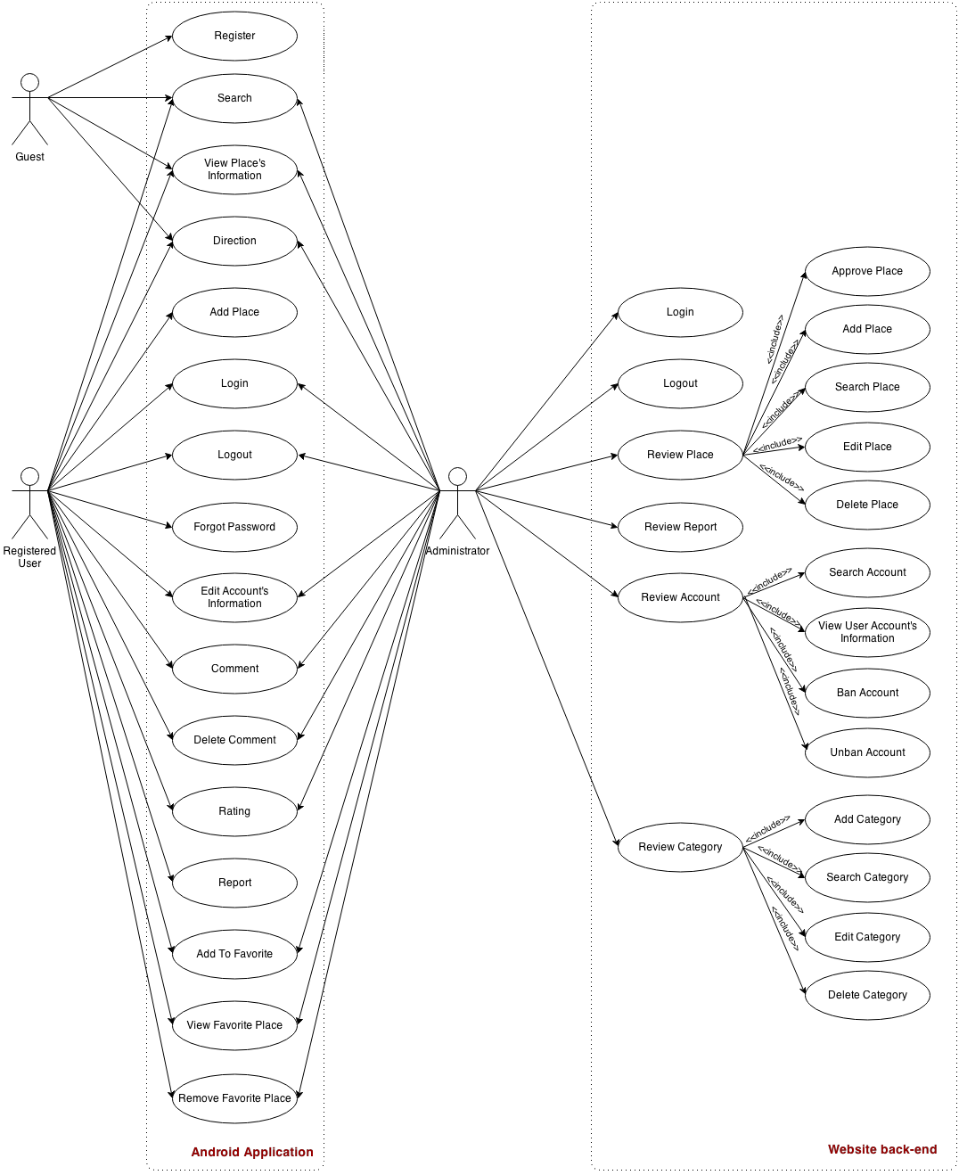

Figure 3‑1 : Use case diagram

#### Use Case Specification

##### Android Application

###### Login

|  |  |  |  |  |
| --- | --- | --- | --- | --- |
| **USE CASE – 001 SPECIFICATION** | | | | |
| **Use-case No.** | UC-001 | **Use-case Version** | | 0.1 |
| **Use-case Name** | Login | | | |
| **Author** | DucDA | | | |
| **Date** | 18/01/2014 | **Priority** | High | |
| **Actor:**  User not log in.  **Summary:**  User can be login with his/her account.  **Goal:**  User login successful to this application.  **Triggers:**  N/A  **Preconditions:**   * User access to application.   **PostConditions:**   * User logged to application.   **Main Success Scenario:**   |  |  |  | | --- | --- | --- | | Step | User | System | | 1 | - User input username and password.  - Click “Đăng nhập” button. | - If username and password is incorrect, show error message “Tên đăng nhập/mật khẩu của bạn không đúng.”.  - If correct, direct to Home Screen. |   **Alternative Scenario:**  N/A  **Exceptions:**  N/A  **Relationships:**  N/A  **Business Rules:**   * In order to log in to the system, username and password are required existed. | | | | |

###### Logout

|  |  |  |  |  |
| --- | --- | --- | --- | --- |
| **USE CASE – 002 SPECIFICATION** | | | | |
| **Use-case No.** | UC-002 | **Use-case Version** | | 0.1 |
| **Use-case Name** | Logout | | | |
| **Author** | DucDA | | | |
| **Date** | 18/01/2014 | **Priority** | High | |
| **Actor:**  Logged User.  **Summary:**  User must be log out from this application.  **Goal:**  User successful log out from this application.  **Triggers:**  Click on “Đăng Xuất” button in the area on top right of the application.  **Preconditions:**   * User logged to application.   **PostConditions:**   * User log out from this application.   **Main Success Scenario:**   |  |  |  | | --- | --- | --- | | Step | User | System | | 1 | -Click “Đăng Xuất” button. | - Direct to Login Screen |   **Alternative Scenario:**  N/A  **Exceptions:**  N/A  **Relationships:**  With use case:   * UC-001: Login.   **Business Rules:**  N/A | | | | |

###### Register

|  |  |  |  |  |
| --- | --- | --- | --- | --- |
| **USE CASE – 003 SPECIFICATION** | | | | |
| **Use-case No.** | UC-003 | **Use-case Version** | | 0.1 |
| **Use-case Name** | Register | | | |
| **Author** | DucDA | | | |
| **Date** | 18/01/2014 | **Priority** | High | |
| **Actor:**  User not log in.  **Summary:**  Allow user to register an account to login to application.  **Goal:**  Complete creating an account that can be used to login to this application.  **Triggers:**  N/A  **Preconditions:**   * User using this application.   **PostConditions:**   * An account can login to this application.   **Main Success Scenario:**   |  |  |  | | --- | --- | --- | | Step | User | System | | 1 | -In Login Screen, user touch “Đăng ký” button. | - Direct to Login Screen | | 2 | - User input enough information and click “Lưu”. | - If username or email is existing, show “Tên đăng nhập/email đã được sử dụng.”  - If email is not corrent, show “Email không chính xác.”  - If all items are correct show alert message register successfully and direct to Login Screen. |   **Alternative Scenario:**  N/A  **Exceptions:**  N/A  **Relationships:**  With use case:   * UC-001: Login.   **Business Rules:**   * User must input correct information to register an account. | | | | |

###### Search Place

|  |  |  |  |  |
| --- | --- | --- | --- | --- |
| **USE CASE – 004 SPECIFICATION** | | | | |
| **Use-case No.** | UC-004 | **Use-case Version** | | 0.1 |
| **Use-case Name** | Searching Place | | | |
| **Author** | DucDA | | | |
| **Date** | 18/01/2014 | **Priority** | High | |
| **Actor:**  Registered User, Guest, Administrator.  **Summary:**  Everyone can search place.  **Goal:**  Using searching location to helping user find location for their traveling.  **Triggers:**  N/A  **Preconditions:**   * User using this application.   **Post Conditions:**   * System must return all of location matching searching input and show them in map with flags.   **Main Success Scenario:**   |  |  |  | | --- | --- | --- | | Step | User | System | | 1 | Enter explorer tab.  Choose category and type of search: - Normal search: User chooses a value of radius and click “Tìm Địa Điểm”.  - Advance search: User draw a search area and click “Tìm Địa Điểm”. | Request to server for searching function.  Return result list to client.  Show result in a map, each place is marked by a flag. |   **Alternative Scenario:**  N/A  **Exceptions:**  N/A  **Relationships:**  N/A  **Business Rules:**  N/A | | | | |

###### View Place’s Information

|  |  |  |  |  |
| --- | --- | --- | --- | --- |
| **USE CASE – 005 SPECIFICATION** | | | | |
| **Use-case No.** | UC-005 | **Use-case Version** | | 0.1 |
| **Use-case Name** | Viewing Place’s Information | | | |
| **Author** | DucDA | | | |
| **Date** | 18/01/2014 | **Priority** | High | |
| **Actor:**  Registered User, Guest, Administrator.  **Summary:**  User chooses a place and view detail information.  **Goal:**  To view detail of place information.  **Triggers:**  N/A  **Preconditions:**   * User using this application.   **Post Conditions:**   * Display detail information.   **Main Success Scenario:**   |  |  |  | | --- | --- | --- | | Step | User | System | | 1 | User chooses place | Display enough place information. (Refer to Place’s Detail Screen) |   **Alternative Scenario:**  N/A  **Exceptions:**  N/A  **Relationships:**  With use case:   * UC-004: Search Place.   **Business Rules:**  N/A | | | | |

###### Direction

|  |  |  |  |  |
| --- | --- | --- | --- | --- |
| **USE CASE – 006 SPECIFICATION** | | | | |
| **Use-case No.** | UC-006 | **Use-case Version** | | 0.1 |
| **Use-case Name** | Direction | | | |
| **Author** | DucDA | | | |
| **Date** | 18/01/2014 | **Priority** | High | |
| **Actor:**  Registered User, Guest, Administrator.  **Summary:**  User chooses location or place and view direction.  **Goal:**  To view direction from user’s location to place where user chosen.  **Triggers:**  N/A  **Preconditions:**   * User using this application.   **Post Conditions:**   * Display direction.   **Main Success Scenario:**   |  |  |  | | --- | --- | --- | | Step | User | System | | 1 | User chooses location or place and click “Tìm Chỉ Đường” button. | Display a direction on map. |   **Alternative Scenario:**  N/A  **Exceptions:**  N/A  **Relationships:**  With use case:   * UC-004: Search Place. * UC-005: View Place’s Information.   **Business Rules:**  N/A | | | | |

###### Edit Account’s Information

|  |  |  |  |  |
| --- | --- | --- | --- | --- |
| **USE CASE – 007 SPECIFICATION** | | | | |
| **Use-case No.** | UC-007 | **Use-case Version** | | 0.1 |
| **Use-case Name** | Editing Account’s Information | | | |
| **Author** | DucDA | | | |
| **Date** | 18/01/2014 | **Priority** | High | |
| **Actor:**  Any logged-in user  **Summary:**  In own User’s Information Page, a user can update his/her profile information  **Goal:**  To edit the information in user’s profile  **Triggers:**  N/A  **Preconditions:**   * User already logged in and accessed his/her own User’s Information Page.   **Post Conditions:**   * User’s information is updated.   **Main Success Scenario:**   |  |  |  | | --- | --- | --- | | Step | User | System | | 1 | Click on “Chỉnh sửa thông tin” option. | Redirect to User Information Editing Page. | | 2 | Insert new information or update the old ones. |  | | 3 | Click on “Lưu” button. | Update user’s information. |   **Alternative Scenario:**  N/A  **Exceptions:**  N/A  **Relationships:**  With use case:   * UC-001: Login.   **Business Rules:**  N/A | | | | |

###### Forgot Password

|  |  |  |  |  |
| --- | --- | --- | --- | --- |
| **USE CASE – 008 SPECIFICATION** | | | | |
| **Use-case No.** | UC-008 | **Use-case Version** | | 0.1 |
| **Use-case Name** | Forgot Password | | | |
| **Author** | DucDA | | | |
| **Date** | 18/01/2014 | **Priority** | High | |
| **Actor:**  User not log in.  **Summary:**  User can request a new password if his/her forgot the current password.  **Goal:**  System sends a random password to his/her email.  **Triggers:**  N/A  **Preconditions:**   * User access to application.   **Post Conditions:**   * User access to application.   **Main Success Scenario:**   |  |  |  | | --- | --- | --- | | Step | User | System | | 1 | Click on “Quên Mật Khẩu” option. | Redirect to Forgot Password Page. | | 2 | Insert email which registered this account. |  | | 3 | Click on “Gửi” button. | - If username and email is incorrect, show error message “Tên đăng nhập/Email của bạn không đúng.”.  - If correct, system sends a random password to his/her email. |   **Alternative Scenario:**  N/A  **Exceptions:**  N/A  **Relationships:**  N/A  **Business Rules:**  In order to send password to email, user name and email are required existed. | | | | |

###### Rating

|  |  |  |  |  |
| --- | --- | --- | --- | --- |
| **USE CASE – 009 SPECIFICATION** | | | | |
| **Use-case No.** | UC-009 | **Use-case Version** | | 0.1 |
| **Use-case Name** | Rating | | | |
| **Author** | DucDA | | | |
| **Date** | 18/01/2014 | **Priority** | High | |
| **Actor:**  Registered User.  **Summary:**  A logged in user can rating place by choose a star-ratings in a place’s information.  **Goal:**  Using user voting to calculate place for rating location. The result is showing in a place’s information.  **Triggers:**  N/A  **Preconditions:**   * User must be logged in and view place’s information.   **Post Conditions:**   * User must log in and view place to rating.   **Main Success Scenario:**   |  |  |  | | --- | --- | --- | | Step | User | System | | 1 | View place’s information. Show star-ratings. | Show place’s information. | | 2 | Rating by choose a point star-ratings. | Send point of place to the server. |   **Alternative Scenario:**  N/A  **Exceptions:**  N/A  **Relationships:**  With use case:   * UC-001: Login. * UC-004: Search Place * UC-005: View Place’s Information   **Business Rules:**  N/A | | | | |

###### Comment

|  |  |  |  |  |
| --- | --- | --- | --- | --- |
| **USE CASE – 010 SPECIFICATION** | | | | |
| **Use-case No.** | UC-010 | **Use-case Version** | | 0.1 |
| **Use-case Name** | Comment | | | |
| **Author** | DucDA | | | |
| **Date** | 18/01/2014 | **Priority** | High | |
| **Actor:**  Registered User.  **Summary:**  User writes comment and clicks “Gửi” to post comment.  **Goal:**  Comment for a place.  **Triggers:**  N/A  **Preconditions:**   * User must be logged in and view place’s information.   **PostConditions:**   * Data will be display on application.   **Main Success Scenario:**   |  |  |  | | --- | --- | --- | | Step | User | System | | 1 | - User chooses place want to writing comment and click “Bình Luận”. | Display comment box. | | 2 | - User writing comment and click button “Gửi”. | Display comment. |   **Alternative Scenario:**  N/A  **Exceptions:**  N/A  **Relationships:**  With use case:   * UC-001: Login. * UC-004: Search Place * UC-005: View Place’s Information   **Business Rules:**  N/A | | | | |

###### Delete Comment

|  |  |  |  |  |
| --- | --- | --- | --- | --- |
| **USE CASE – 011 SPECIFICATION** | | | | |
| **Use-case No.** | UC-011 | **Use-case Version** | | 0.1 |
| **Use-case Name** | Delete Comment | | | |
| **Author** | DucDA | | | |
| **Date** | 18/01/2014 | **Priority** | High | |
| **Actor:**  Registered User, Administrator.  **Summary:**  User can delete her/his own comment. Administrator can delete all comments.  **Goal:**  Comment has been deleted.  **Triggers:**  N/A  **Preconditions:**   * User must be logged in and view his/her comment.   **PostConditions:**   * Data will be display on application.   **Main Success Scenario:**   |  |  |  | | --- | --- | --- | | Step | User | System | | 1 | - User chooses comment want to delete and click “x”. | System will show a question “Bạn có muốn xóa bình luận này không?” | | 2 | - User click button “Có”. | Delete comment. |   **Alternative Scenario:**  N/A  **Exceptions:**  N/A  **Relationships:**  With use case:   * UC-001: Login. * UC-004: Search Place * UC-005: View Place’s Information   **Business Rules:**  N/A | | | | |

###### Report

|  |  |  |  |  |
| --- | --- | --- | --- | --- |
| **USE CASE – 012 SPECIFICATION** | | | | |
| **Use-case No.** | UC-012 | **Use-case Version** | | 0.1 |
| **Use-case Name** | Report | | | |
| **Author** | DucDA | | | |
| **Date** | 18/01/2014 | **Priority** | High | |
| **Actor:**  Registered User.  **Summary:**  User can report bad and incorrect place.  **Goal:**  Send report to sever.  **Triggers:**  N/A  **Preconditions:**   * User must be logged in and view place’s information   **PostConditions:**   * Report sent to server.   **Main Success Scenario:**   |  |  |  | | --- | --- | --- | | Step | User | System | | 1 | Click on “Báo Cáo Sai Phạm” button under the full content of Place’s Information | Show a Report Page | | 2 | Input purport of report and click “Gửi” button | Send report to server. |   **Alternative Scenario:**  N/A  **Exceptions:**  N/A  **Relationships:**  With use case:   * UC-001: Login. * UC-004: Search Place * UC-005: View Place’s Information   **Business Rules:**  N/A | | | | |

###### Add To Favorite

|  |  |  |  |  |
| --- | --- | --- | --- | --- |
| **USE CASE – 013 SPECIFICATION** | | | | |
| **Use-case No.** | UC-013 | **Use-case Version** | | 0.1 |
| **Use-case Name** | Add To Favorite | | | |
| **Author** | DucDA | | | |
| **Date** | 18/01/2014 | **Priority** | High | |
| **Actor:**  Registered User, Administrator.  **Summary:**  User can add place to his/her favorite list.  **Goal:**  Place can be add to favorite list.  **Triggers:**  N/A  **Preconditions:**   * User must be logged in and view place’s information   **PostConditions:**   * This place added to user’s favorite list.   **Main Success Scenario:**   |  |  |  | | --- | --- | --- | | Step | User | System | | 1 | Click on “Địa Điểm Ưa Thích” button under the full content of Place’s Information | Add place to favorite list. |   **Alternative Scenario:**  N/A  **Exceptions:**  N/A  **Relationships:**  With use case:   * UC-001: Login. * UC-004: Search Place * UC-005: View Place’s Information   **Business Rules:**  N/A | | | | |

###### View Favorite Place

|  |  |  |  |  |
| --- | --- | --- | --- | --- |
| **USE CASE – 014 SPECIFICATION** | | | | |
| **Use-case No.** | UC-014 | **Use-case Version** | | 0.1 |
| **Use-case Name** | View Favorite Place | | | |
| **Author** | DucDA | | | |
| **Date** | 18/01/2014 | **Priority** | High | |
| **Actor:**  Registered User, Administrator.  **Summary:**  User can view his/her favorite place.  **Goal:**  List of user’s favorite place can show.  **Triggers:**  N/A  **Preconditions:**   * User must be logged in.   **PostConditions:**   * Data will be display on application.   **Main Success Scenario:**   |  |  |  | | --- | --- | --- | | Step | User | System | | 1 | Click on “Địa Điểm Ưa Thích” button in a main page | Show list of favorite place. |   **Alternative Scenario:**  N/A  **Exceptions:**  N/A  **Relationships:**  With use case:   * UC-001: Login.   **Business Rules:**  N/A | | | | |

###### Remove Favorite Place

|  |  |  |  |  |
| --- | --- | --- | --- | --- |
| **USE CASE – 015 SPECIFICATION** | | | | |
| **Use-case No.** | UC-015 | **Use-case Version** | | 0.1 |
| **Use-case Name** | Remove Favorite Place | | | |
| **Author** | DucDA | | | |
| **Date** | 18/01/2014 | **Priority** | High | |
| **Actor:**  Registered User, Administrator.  **Summary:**  User can remove his/her favorite place.  **Goal:**  This place will be removed from user’s favorite list.  **Triggers:**  N/A  **Preconditions:**   * User must be logged in.   **PostConditions:**   * This place removed from user’s favorite list.   **Main Success Scenario:**   |  |  |  | | --- | --- | --- | | Step | User | System | | 1 | Click on “Địa Điểm Ưa Thích” button in a main page | Show list of favorite place. | | 2 | Click on “Xóa” button | This place should be remove from favorite list. |   **Alternative Scenario:**  N/A  **Exceptions:**  N/A  **Relationships:**  With use case:   * UC-001: Login.   **Business Rules:**  N/A | | | | |

###### Add Place

|  |  |  |  |  |
| --- | --- | --- | --- | --- |
| **USE CASE – 016 SPECIFICATION** | | | | |
| **Use-case No.** | UC-016 | **Use-case Version** | | 0.1 |
| **Use-case Name** | Add Place | | | |
| **Author** | DucDA | | | |
| **Date** | 18/01/2014 | **Priority** | High | |
| **Actor:**  Registered User.  **Summary:**  User can add new place. This place should be reviewed and approved by administrator before publish.  **Goal:**  User can send new place and information to server.  **Triggers:**  N/A  **Preconditions:**   * User must be logged in.   **PostConditions:**   * Data sent to server.   **Main Success Scenario:**   |  |  |  | | --- | --- | --- | | Step | User | System | | 1 | Click on “Thêm Địa Đim” buttonin a main page | Show map. | | 2 | Choose a place want to add by click in map | Show pop-up to input place’s information. | | 3 | Input information of this place and click “Gửi” button. | Send information of new place to server. |   **Alternative Scenario:**  N/A  **Exceptions:**  N/A  **Relationships:**  With use case:   * UC-001: Login.   **Business Rules:**  N/A | | | | |

##### Website back-end

###### Login

|  |  |  |  |  |
| --- | --- | --- | --- | --- |
| **USE CASE – 017 SPECIFICATION** | | | | |
| **Use-case No.** | UC-017 | **Use-case Version** | | 0.1 |
| **Use-case Name** | Login | | | |
| **Author** | DucDA | | | |
| **Date** | 18/01/2014 | **Priority** | High | |
| **Actor:**  Administrator not log in.  **Summary:**  Administrator can be login with his/her account.  **Goal:**  Administrator successful log in to this website.  **Triggers:**  N/A  **Preconditions:**   * User visit to website.   **PostConditions:**   * User logged to website.   **Main Success Scenario:**   |  |  |  | | --- | --- | --- | | Step | User | System | | 1 | User input username and password.  Click “Đăng nhập” button. | If username and password is incorrect, show error message “Tên đăng nhập/mật khẩu của bạn không đúng.”.  If correct, direct to Home Screen. |   **Alternative Scenario:**  N/A  **Exceptions:**  N/A  **Relationships:**  N/A  **Business Rules:**   * In order to log in to the system, user name and password are required existed. | | | | |

###### Logout

|  |  |  |  |  |
| --- | --- | --- | --- | --- |
| **USE CASE – 018 SPECIFICATION** | | | | |
| **Use-case No.** | UC-018 | **Use-case Version** | | 0.1 |
| **Use-case Name** | Logout | | | |
| **Author** | DucDA | | | |
| **Date** | 18/01/2014 | **Priority** | High | |
| **Actor:**  Administrator.  **Summary:**  Administrator must be log out from this website.  **Goal:**  Administrator successful log out from this website.  **Triggers:**  Click on “Đăng Xuất” button in the area on top right of the website.  **Preconditions:**   * Administrator logged to website.   **PostConditions:**   * Administrator log out from this website.   **Main Success Scenario:**   |  |  |  | | --- | --- | --- | | Step | User | System | | 1 | Click “Đăng Xuất” button. | Direct to Login Screen |   **Alternative Scenario:**  N/A  **Exceptions:**  N/A  **Relationships:**  With use case:   * UC-017: Login.   **Business Rules:**  N/A | | | | |

###### Review Place

Approve Place

|  |  |  |  |  |
| --- | --- | --- | --- | --- |
| **USE CASE – 019 SPECIFICATION** | | | | |
| **Use-case No.** | UC-019 | **Use-case Version** | | 0.1 |
| **Use-case Name** | Approve Place | | | |
| **Author** | DucDA | | | |
| **Date** | 18/01/2014 | **Priority** | High | |
| **Actor:**  Administrator.  **Summary:**  Administrator can approve or decline place add by user.  **Goal:**  New place should be added to database if administrator approve, remove from database if declined.  **Triggers:**  N/A  **Preconditions:**   * Administrator logged to website.   **PostConditions:**   * New place should be approved.   **Main Success Scenario:**   |  |  |  | | --- | --- | --- | | Step | User | System | | 1 | Click “Xem Xét Địa Điểm” option. | Show list of place can review. | | 2 | Choose a place. | Show information of this place. | | 3 | Click “Đồng Ý” or “Hủy Bỏ” button. | New place can be add or not to system. |   **Alternative Scenario:**  N/A  **Exceptions:**  N/A  **Relationships:**  With use case:   * UC-017: Login.   **Business Rules:**  N/A | | | | |

Add Place

|  |  |  |  |  |
| --- | --- | --- | --- | --- |
| **USE CASE – 020 SPECIFICATION** | | | | |
| **Use-case No.** | UC-020 | **Use-case Version** | | 0.1 |
| **Use-case Name** | Add Place | | | |
| **Author** | DucDA | | | |
| **Date** | 18/01/2014 | **Priority** | High | |
| **Actor:**  Administrator.  **Summary:**  Administrator can add new place to database.  **Goal:**  New place should be added.  **Triggers:**  N/A  **Preconditions:**   * Administrator logged to website.   **PostConditions:**   * New place should be added.   **Main Success Scenario:**   |  |  |  | | --- | --- | --- | | Step | User | System | | 1 | Click “Thêm Địa Điểm” option. | Open “Add Place” page. | | 2 | Input information of new place and click “Thêm”. | New place can be add or not to system. |   **Alternative Scenario:**  N/A  **Exceptions:**  N/A  **Relationships:**  With use case:   * UC-017: Login.   **Business Rules:**  N/A | | | | |

Search Place

|  |  |  |  |  |
| --- | --- | --- | --- | --- |
| **USE CASE – 021 SPECIFICATION** | | | | |
| **Use-case No.** | UC-021 | **Use-case Version** | | 0.1 |
| **Use-case Name** | Search Place | | | |
| **Author** | DucDA | | | |
| **Date** | 18/01/2014 | **Priority** | High | |
| **Actor:**  Administrator.  **Summary:**  Administrator can search place from database.  **Goal:**  Return a list of place.  **Triggers:**  N/A  **Preconditions:**   * Administrator logged to website.   **PostConditions:**   * Result list showed.   **Main Success Scenario:**   |  |  |  | | --- | --- | --- | | Step | User | System | | 1 | Input a word or choose a category and click “Tìm Kiếm”. | Show result list. |   **Alternative Scenario:**  N/A  **Exceptions:**  N/A  **Relationships:**  With use case:   * UC-017: Login.   **Business Rules:**  N/A | | | | |

Edit Place

|  |  |  |  |  |
| --- | --- | --- | --- | --- |
| **USE CASE – 022 SPECIFICATION** | | | | |
| **Use-case No.** | UC-022 | **Use-case Version** | | 0.1 |
| **Use-case Name** | Edit Place | | | |
| **Author** | DucDA | | | |
| **Date** | 18/01/2014 | **Priority** | High | |
| **Actor:**  Administrator.  **Summary:**  Administrator can edit information of place.  **Goal:**  New information of place should be added to database.  **Triggers:**  N/A  **Preconditions:**   * Administrator logged to website.   **PostConditions:**   * New information of place updated.   **Main Success Scenario:**   |  |  |  | | --- | --- | --- | | Step | User | System | | 1 | Choose a place and click “Sửa Thông Tin” | Display “Edit Place” Screen. | | 2 | Edit information of place and click “Cập Nhật” | This place should be updated. |   **Alternative Scenario:**  N/A  **Exceptions:**  N/A  **Relationships:**  With use case:   * UC-017: Login.   **Business Rules:**  N/A | | | | |

Delete Place

|  |  |  |  |  |
| --- | --- | --- | --- | --- |
| **USE CASE – 023 SPECIFICATION** | | | | |
| **Use-case No.** | UC-023 | **Use-case Version** | | 0.1 |
| **Use-case Name** | Delete Place | | | |
| **Author** | DucDA | | | |
| **Date** | 18/01/2014 | **Priority** | High | |
| **Actor:**  Administrator.  **Summary:**  Administrator can delete place.  **Goal:**  This place deleted.  **Triggers:**  N/A  **Preconditions:**   * Administrator logged to website.   **PostConditions:**   * This place deleted from database.   **Main Success Scenario:**   |  |  |  | | --- | --- | --- | | Step | User | System | | 1 | Choose a place and click “Xóa” | Show question “Bạn có muốn xóa địa điểm này không?” | | 2 | Choose “Có” | This place should be deleted. |   **Alternative Scenario:**  N/A  **Exceptions:**  N/A  **Relationships:**  With use case:   * UC-017: Login.   **Business Rules:**  N/A | | | | |

###### Review Report

|  |  |  |  |  |
| --- | --- | --- | --- | --- |
| **USE CASE – 024 SPECIFICATION** | | | | |
| **Use-case No.** | UC-024 | **Use-case Version** | | 0.1 |
| **Use-case Name** | Review Report | | | |
| **Author** | DucDA | | | |
| **Date** | 18/01/2014 | **Priority** | High | |
| **Actor:**  Administrator.  **Summary:**  Administrator can review report send by user.  **Goal:**  Administrator can view report to resolve it.  **Triggers:**  N/A  **Preconditions:**   * Administrator logged to website.   **PostConditions:**   * Administrator log out from this website.   **Main Success Scenario:**   |  |  |  | | --- | --- | --- | | Step | User | System | | 1 | Click “Xem Báo Sai Phạm” option. | Show list of report can review. | | 2 | Choose a place. | Show content of this report. |   **Alternative Scenario:**  N/A  **Exceptions:**  N/A  **Relationships:**  With use case:   * UC-017: Login.   **Business Rules:**  N/A | | | | |

###### Review Account

Search Account

|  |  |  |  |  |
| --- | --- | --- | --- | --- |
| **USE CASE – 025 SPECIFICATION** | | | | |
| **Use-case No.** | UC-025 | **Use-case Version** | | 0.1 |
| **Use-case Name** | Search Account | | | |
| **Author** | DucDA | | | |
| **Date** | 18/01/2014 | **Priority** | High | |
| **Actor:**  Administrator.  **Summary:**  Administrator can search account from database.  **Goal:**  Return a list of accounts.  **Triggers:**  N/A  **Preconditions:**   * Administrator logged to website.   **PostConditions:**   * Result list showed.   **Main Success Scenario:**   |  |  |  | | --- | --- | --- | | Step | User | System | | 1 | Input a word or choose a category and click “Tìm Kiếm”. | Show result list. |   **Alternative Scenario:**  N/A  **Exceptions:**  N/A  **Relationships:**  With use case:   * UC-017: Login.   **Business Rules:**  N/A | | | | |

View User Account’s Information

|  |  |  |  |  |
| --- | --- | --- | --- | --- |
| **USE CASE – 026 SPECIFICATION** | | | | |
| **Use-case No.** | UC-026 | **Use-case Version** | | 0.1 |
| **Use-case Name** | View User Account’s Information | | | |
| **Author** | DucDA | | | |
| **Date** | 18/01/2014 | **Priority** | High | |
| **Actor:**  Administrator.  **Summary:**  Administrator can view user account’s information.  **Goal:**  Show information of account.  **Triggers:**  N/A  **Preconditions:**   * Administrator logged to website.   **PostConditions:**   * Account’s information showed.   **Main Success Scenario:**   |  |  |  | | --- | --- | --- | | Step | User | System | | 1 | Choose one account and click “Xem Thông Tin” | Show account’s information. |   **Alternative Scenario:**  N/A  **Exceptions:**  N/A  **Relationships:**  With use case:   * UC-017: Login.   **Business Rules:**  N/A | | | | |

Ban Account

|  |  |  |  |  |
| --- | --- | --- | --- | --- |
| **USE CASE – 027 SPECIFICATION** | | | | |
| **Use-case No.** | UC-027 | **Use-case Version** | | 0.1 |
| **Use-case Name** | Ban Account | | | |
| **Author** | DucDA | | | |
| **Date** | 18/01/2014 | **Priority** | High | |
| **Actor:**  Administrator.  **Summary:**  Administrator can ban user’s account.  **Goal:**  User’s account should be disabled.  **Triggers:**  N/A  **Preconditions:**   * Administrator logged to website.   **PostConditions:**   * User’s account disabled.   **Main Success Scenario:**   |  |  |  | | --- | --- | --- | | Step | User | System | | 1 | Click on “Khóa Tài Khoản” button under the full content of Account’s Information | System will show a question “Bạn có muốn khóa tài khoản này không?” | | 2 | Choose “Có” button | Account should be disabled. |   **Alternative Scenario:**  N/A  **Exceptions:**  N/A  **Relationships:**  With use case:   * UC-017: Login. * UC-026: View User Account’s Information   **Business Rules:**  N/A | | | | |

Unban Account

|  |  |  |  |  |
| --- | --- | --- | --- | --- |
| **USE CASE – 028 SPECIFICATION** | | | | |
| **Use-case No.** | UC-028 | **Use-case Version** | | 0.1 |
| **Use-case Name** | Unban Account | | | |
| **Author** | DucDA | | | |
| **Date** | 18/01/2014 | **Priority** | High | |
| **Actor:**  Administrator.  **Summary:**  Administrator can unban user’s account.  **Goal:**  User’s account should be enabled.  **Triggers:**  N/A  **Preconditions:**   * Administrator logged to website.   **PostConditions:**   * User’s account enabled.   **Main Success Scenario:**   |  |  |  | | --- | --- | --- | | Step | User | System | | 1 | Click on “Mở Khóa Tài Khoản” button under the full content of Account’s Information | System will show a question “Bạn có muốn mở khóa tài khoản này không?” | | 2 | Choose “Có” button | Account should be enabled. |   **Alternative Scenario:**  N/A  **Exceptions:**  N/A  **Relationships:**  With use case:   * UC-017: Login. * UC-026: View User Account’s Information   **Business Rules:**  N/A | | | | |

###### Review Category

Add Category

|  |  |  |  |  |
| --- | --- | --- | --- | --- |
| **USE CASE – 029 SPECIFICATION** | | | | |
| **Use-case No.** | UC-029 | **Use-case Version** | | 0.1 |
| **Use-case Name** | Add Category | | | |
| **Author** | DucDA | | | |
| **Date** | 18/01/2014 | **Priority** | High | |
| **Actor:**  Administrator.  **Summary:**  Administrator can add new category to database.  **Goal:**  New category should be added.  **Triggers:**  N/A  **Preconditions:**   * Administrator logged to website.   **PostConditions:**   * New category added to database.   **Main Success Scenario:**   |  |  |  | | --- | --- | --- | | Step | User | System | | 1 | Click “Thêm Mục” option. | Open “Add Category” page. | | 2 | Input information of new category and click “Thêm”. | New category can be add or not to system. |   **Alternative Scenario:**  N/A  **Exceptions:**  N/A  **Relationships:**  With use case:   * UC-017: Login.   **Business Rules:**  N/A | | | | |

Search Category

|  |  |  |  |  |
| --- | --- | --- | --- | --- |
| **USE CASE – 030 SPECIFICATION** | | | | |
| **Use-case No.** | UC-030 | **Use-case Version** | | 0.1 |
| **Use-case Name** | Search Category | | | |
| **Author** | DucDA | | | |
| **Date** | 18/01/2014 | **Priority** | High | |
| **Actor:**  Administrator.  **Summary:**  Administrator can search category from database.  **Goal:**  Return a list of category.  **Triggers:**  N/A  **Preconditions:**   * Administrator logged to website.   **PostConditions:**   * Result list showed.   **Main Success Scenario:**   |  |  |  | | --- | --- | --- | | Step | User | System | | 1 | Input a word and click “Tìm Kiếm”. | Show result list. |   **Alternative Scenario:**  N/A  **Exceptions:**  N/A  **Relationships:**  With use case:   * UC-017: Login.   **Business Rules:**  N/A | | | | |

Edit Category

|  |  |  |  |  |
| --- | --- | --- | --- | --- |
| **USE CASE – 031 SPECIFICATION** | | | | |
| **Use-case No.** | UC-031 | **Use-case Version** | | 0.1 |
| **Use-case Name** | Edit Category | | | |
| **Author** | DucDA | | | |
| **Date** | 18/01/2014 | **Priority** | High | |
| **Actor:**  Administrator.  **Summary:**  Administrator can edit information of category.  **Goal:**  New information of category should be added to database.  **Triggers:**  N/A  **Preconditions:**   * Administrator logged to website.   **PostConditions:**   * New information of category updated.   **Main Success Scenario:**   |  |  |  | | --- | --- | --- | | Step | User | System | | 1 | Choose a category and click “Sửa Thông Tin” | Display “Edit Category” Screen. | | 2 | Edit information of category and click “Cập Nhật” | This category should be updated. |   **Alternative Scenario:**  N/A  **Exceptions:**  N/A  **Relationships:**  With use case:   * UC-017: Login.   **Business Rules:**  N/A | | | | |

Delete Category

|  |  |  |  |  |
| --- | --- | --- | --- | --- |
| **USE CASE – 032 SPECIFICATION** | | | | |
| **Use-case No.** | UC-032 | **Use-case Version** | | 0.1 |
| **Use-case Name** | Delete Category | | | |
| **Author** | DucDA | | | |
| **Date** | 18/01/2014 | **Priority** | High | |
| **Actor:**  Administrator.  **Summary:**  Administrator can delete category.  **Goal:**  This category deleted.  **Triggers:**  N/A  **Preconditions:**   * Administrator logged to website.   **PostConditions:**   * This category deleted from database.   **Main Success Scenario:**   |  |  |  | | --- | --- | --- | | Step | User | System | | 1 | Choose a category and click “Xóa” | Show question “Bạn có muốn xóa mục này không?” | | 2 | Choose “Có” | This category should be deleted. |   **Alternative Scenario:**  N/A  **Exceptions:**  N/A  **Relationships:**  With use case:   * UC-017: Login.   **Business Rules:**  N/A | | | | |

## Entity Relationship Diagram or Data Structures

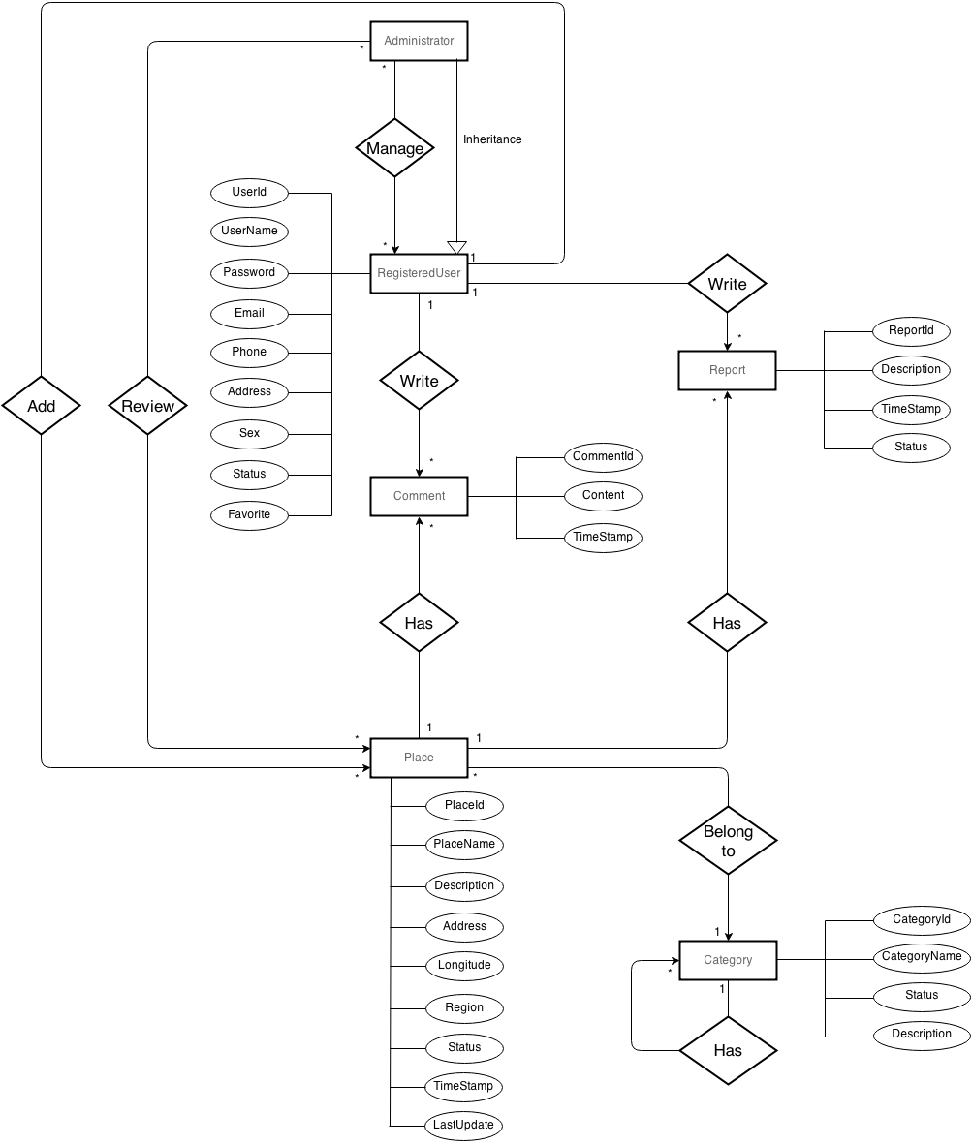

Figure 3‑2 : Entity Relationship Diagram

# Software Design Description

## Design Overview

This document describes the technical and User Interface Design of the SPlace system, include the architectural design and the detailed design of common functions and business functions. It also includes the design of database model and overall design of user interface.

The architecture design describes the overall architectural of the system, and the architecture of main components and subsystems. It will describe the patterns besing used, the role of each component and the role of the system in the working environment.

The detailed design describes static and dynamic structure for each component and function. It include class diagrams and sequence diagrams of the main use cases.

The database design describes the relationship between entities and details of each entity. It uses notations of MySQL as the database server for developing the system.

The user interface design describes the layout of the system, and some design for the screens of admin page and application.

## System Architectural Design

### Choice of System Architecture

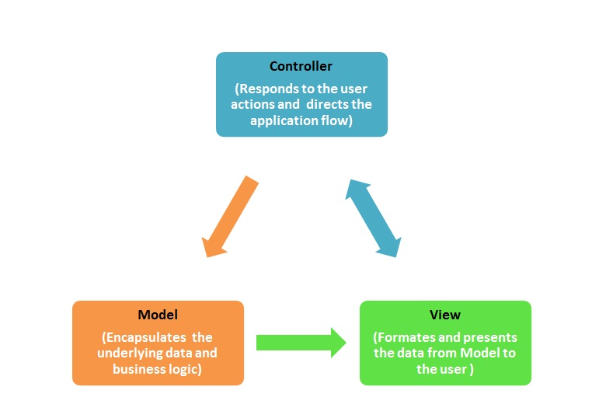

Figure 4‑1 : MVC Pattern

The system will use the Client Server architectural patterns as the main architecture. It makes use of the Internet and common web protocols to deliver data between web serviced and Android Application. The main entities of the above diagram will be described as following :

**Database :** this is the central data storage for the system. It may be running on a separate server to the Application Server, or in the same machine.

**Website Backend:** This website manage all data and activities of this system. This will be based on PHP Laravel Framework that use MVC architecture pattern to implementation.

**WebService :** This provides main services for Android Application and others clients. It will be based on PHP Laravel Framework to transfer JSON data to Android.

**Android Application:** The mobile applications use to manage and display UI. It will be based on SOA pattern to interact with the server via web services.

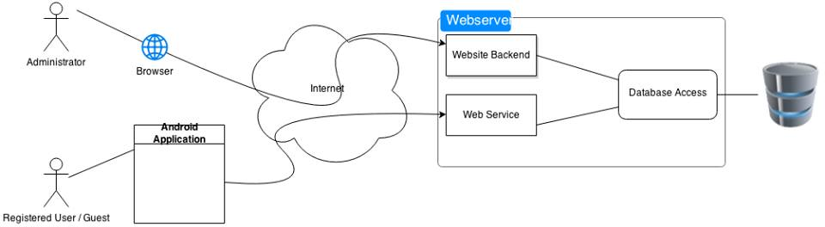

Figure 4‑2 : Design Overview

### Discussion of Alternative Designs

#### Model View Controller

The Model-View-Controller (MVC) design pattern assigns objects in an application one of three roles: model, view, or controller. The pattern defines not only the roles objects play in the application. It defines the way objects communicate with each other. Each of the three types of objects is separated from the others by abstract boundaries and communicates with objects of the other types across those boundaries. The collection of objects of a certain MVC type in an application is sometimes referred to as a layer—for example, model layer.

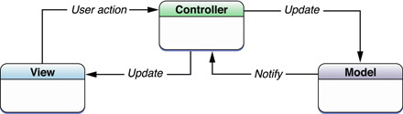

MVC is central to a good design for a Android application. The benefits of adopting this pattern are numerous. Many objects in these applications tend to be more reusable, and their interfaces tend to be better defined. Applications having an MVC design are also more easily extensible than other applications. Moreover, many Android technologies and architectures are based on MVC and require that your custom objects play one of the MVC roles.

Laravel implements the model-view-controller (MVC) design pattern, which is widely adopted in Web programming. MVC aims to separate business logic from user interface considerations, so developers can more easily change each part without affecting the other. In MVC, the model represents the information (the data) and the business rules; the view contains elements of the user interface such as text, form inputs; and the controller manages the communication between the model and the view.

Besides implementing MVC, Laravel also introduces a front-controller, called Application, which encapsulates the execution context for the processing of a request. Application collects some information about a user request and then dispatches it to an appropriate controller for further handling.

#### Service Oriented Architectures (SOA)

SOA is a technique used in software development based on the concept of Service. A service can be defined as an independent function, which is well defined and self-contained. In SOA different services communicate each other to perform some activity. Even two or more services can be synchronized together to perform some complex activities.

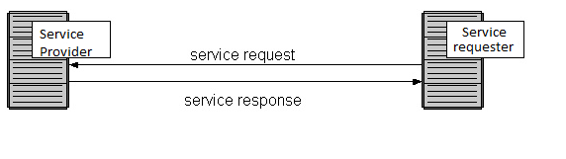

Figure 4‑3 : SOA Architecture

SOA allows you to develop a complex product by integrating different products from different vendors independent of the platform and technology. Thus it helps to manage complexity involved. And making effective use of SOA concepts, client can be competent enough as the time needed for the development is considerably reduced because of the reuse. It allows an organization to leverage existing assets, rather than building a new product from scratch without making use of existing ones. This also reduces the software development cycle and cost involved, thus a faster time-to-market is made possible.

### Description of System Interface

SRS document also refers very detail of Splace interface. In this description, we will generalize 3 main areas of Splace interface, which will be detail so far in this document:

**Web service:** to communicate between server with Android Application.

**Back-end Website:** is the administration area for authenticated user to manage content site setting, site module, etc., due to their privileges.

**Android Application:** is client interact with user.

## Component Diagram

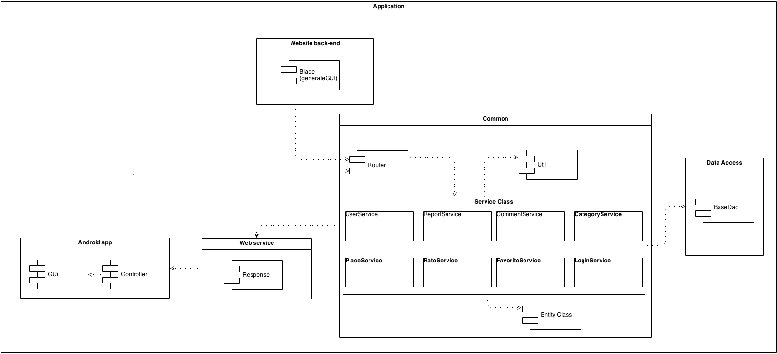

Figure 4‑4 : Component Diagram

## Detailed Description of Components

### CRC Cards (Class-Responsibility-Collaborators)

|  |  |
| --- | --- |
| Responsibilities | Collaborators |
| User | |
| Represent information of an user  Recommend new place, view place  Managed his comment  Send report to system | Place  Comment  Report  UserService  LoginService |

|  |  |
| --- | --- |
| Responsibilities | Collaborators |
| LoginService | |
| Represent business object which do user logic. | User |

|  |  |
| --- | --- |
| Responsibilities | Collaborators |
| UserService | |
| Represent business object which do user logic. | User |

|  |  |
| --- | --- |
| Responsibilities | Collaborators |
| Router | |
| Router request of user | All object service |

|  |  |
| --- | --- |
| Responsibilities | Collaborators |
| CommentService | |
| Represent business object which do comment logic. | comment |
| Responsibilities | Collaborators |
| CategoryService |
| Represent business object which do category logic. | category |

|  |  |
| --- | --- |
| Responsibilities | Collaborators |
| PlaceService | |
| Represent business object which do place logic. | Place |

|  |  |
| --- | --- |
| Responsibilities | Collaborators |
| RateService | |
| Represent business object which do Rate logic. | Rate |

|  |  |
| --- | --- |
| Responsibilities | Collaborators |
| Place | |
| Represent information of place  Recommended and rated by user  Belong to a position  Belong to a category  Belong to a region | User  Position  Category  Region  PlaceService |

|  |  |
| --- | --- |
| Responsibilities | Collaborators |
| Region | |
| Represent information of location where a place belong to | Place |

|  |  |
| --- | --- |
| Responsibilities | Collaborators |
| Rate | |
| Represent feedback of user to a place | Place  RateService |

|  |  |
| --- | --- |
| Responsibilities | Collaborators |
| Comment | |
| Represent feeling of an user to a place  Made by register user | Place  RegisterUser  CommentService |

|  |  |
| --- | --- |
| Responsibilities | Collaborators |
| Report | |
| Represent feedback of a place  Represent feedback of a comment  Made by register user | Place  Comment  RegisterUser |

|  |  |
| --- | --- |
| Responsibilities | Collaborators |
| Category | |
| Represent information of groups place | Place  CategoryService |

|  |  |
| --- | --- |
| Responsibilities | Collaborators |
| Images | |
| Represent image of a place or user | Place  User |

|  |  |
| --- | --- |
| Responsibilities | Collaborators |
| Favorite | |
| Represent favorite place or user | Place  user  FavoriteService |

|  |  |
| --- | --- |
| Responsibilities | Collaborators |
| Cat_place_ref | |
| Represent relation between category and place | Place  Category |

|  |  |
| --- | --- |
| Responsibilities | Collaborators |
| BaseDAO | |
| Work with database. | All entity object. |

### Class Diagram

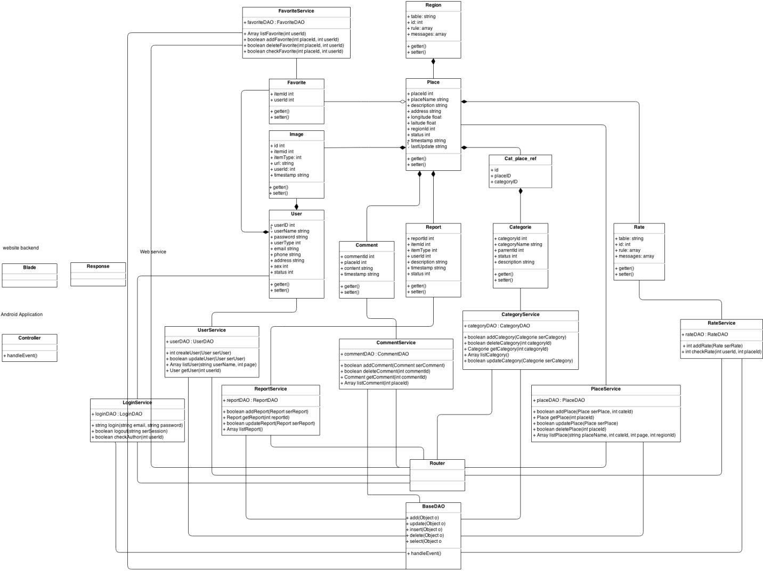

Figure 4‑5 : Class Diagram

### Flow-Chart

#### Add Place

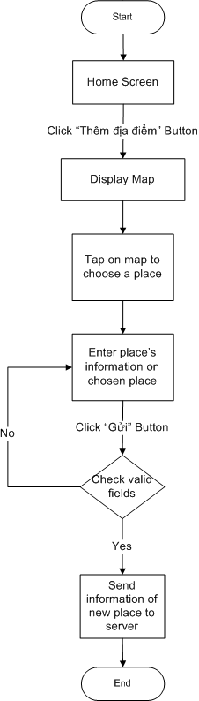

#### Login

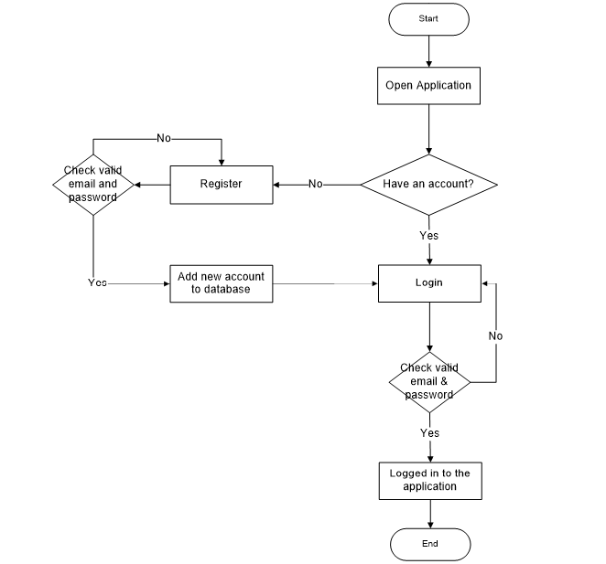

#### Comment

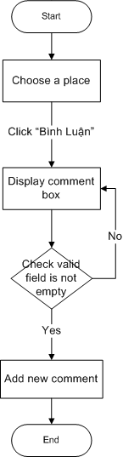

#### Direction

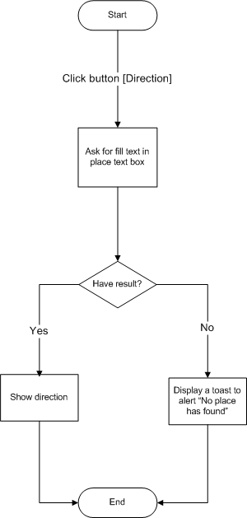

#### Review

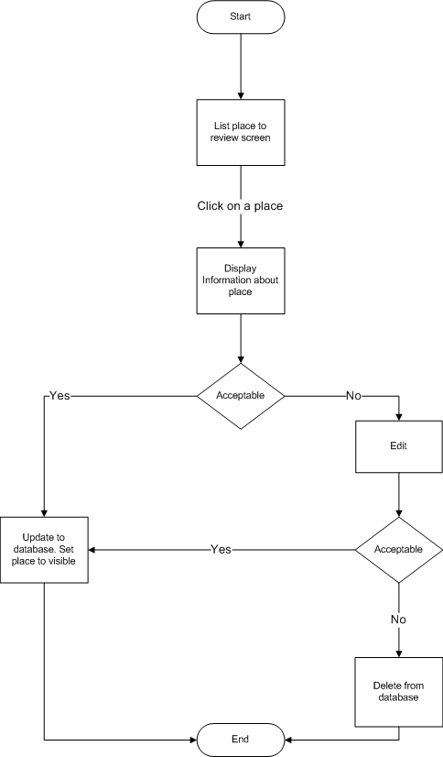

#### Search

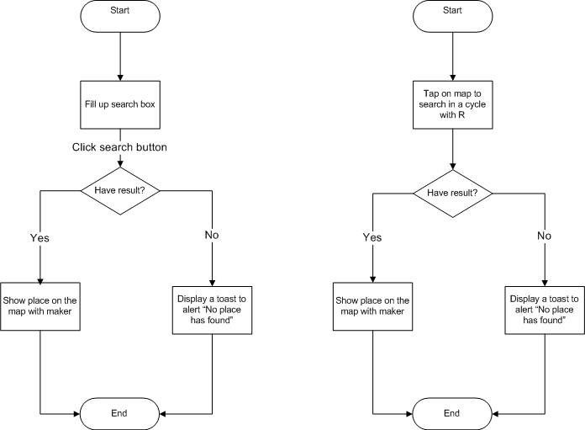

## Sequence Diagram

### Login

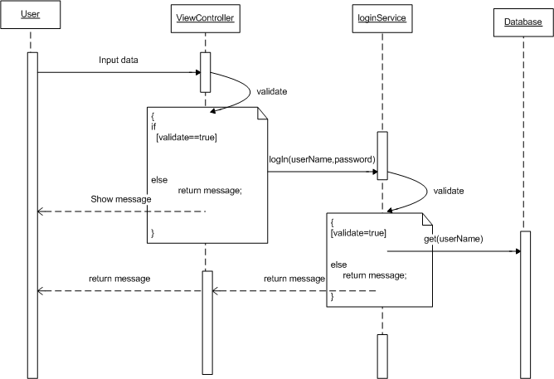

### Add Place

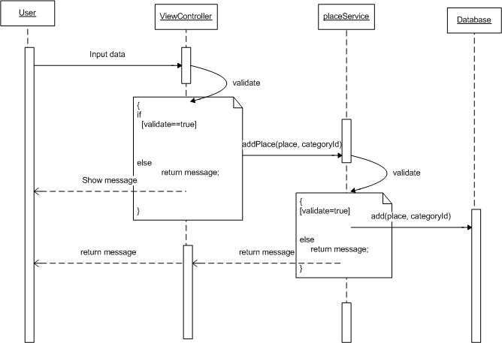

### Comment

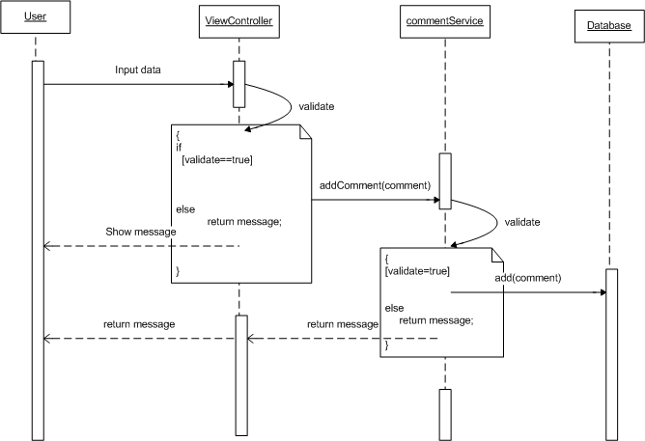

### Search

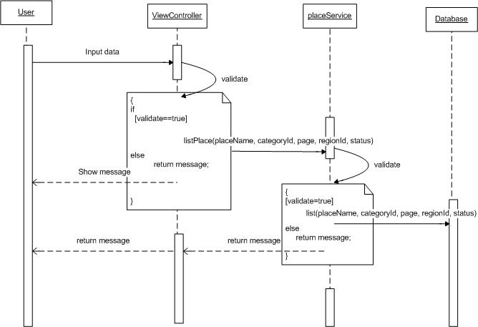

### Get Direction

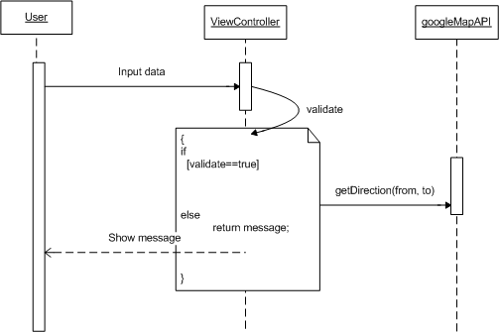

### Review Place

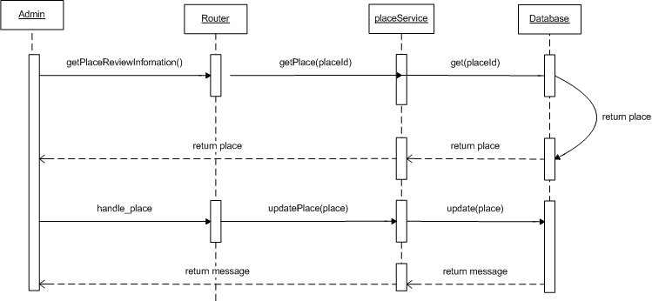

## User Interface Design / Hardware Interface Design

### Sign Up & Sign In

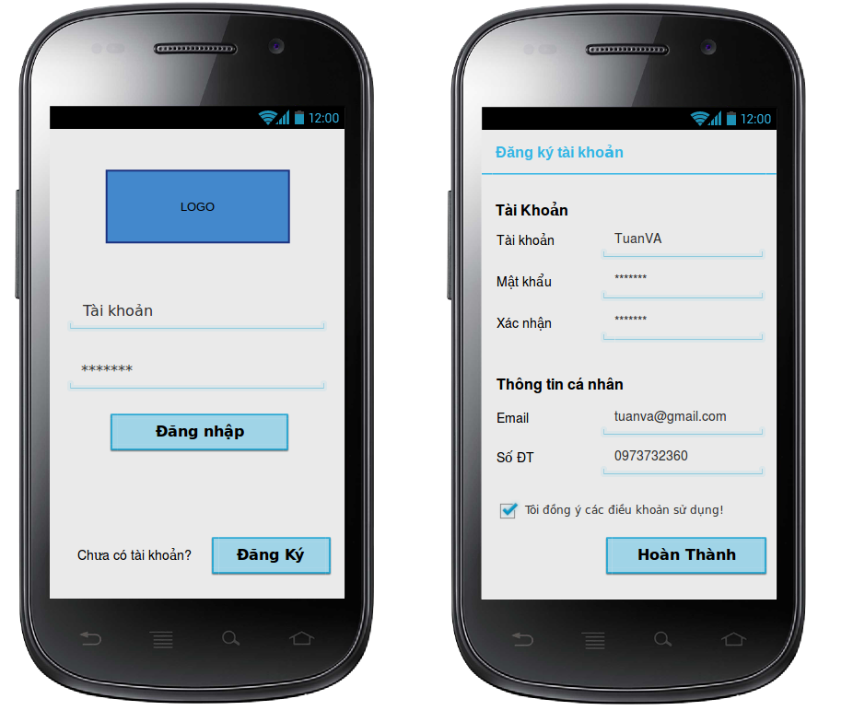

### List Place By category



### List Category

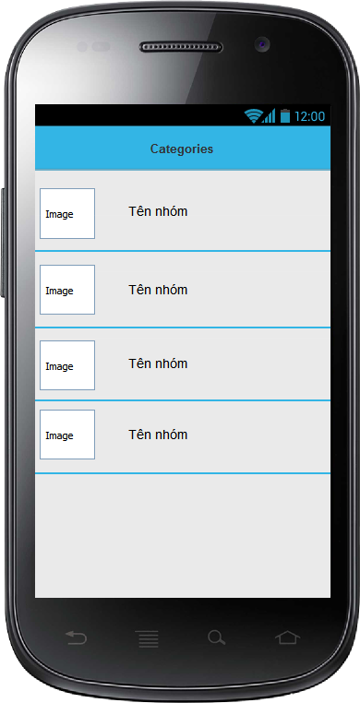

### Get Direction

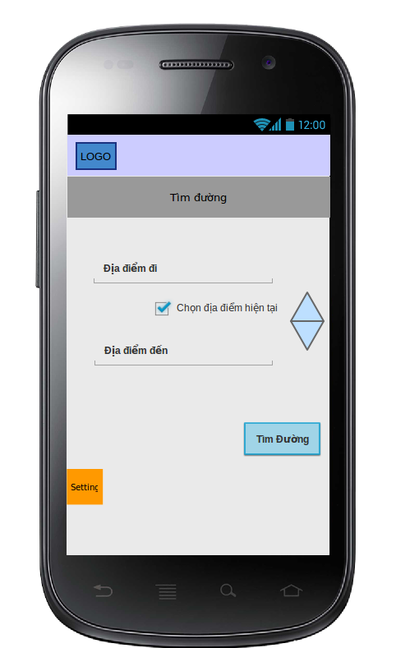



### Search Screen

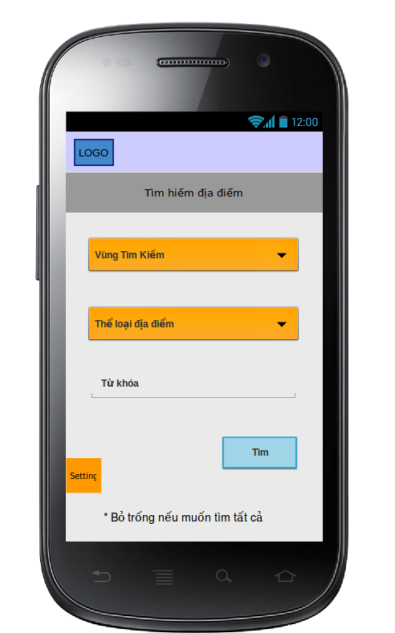

### Add new place

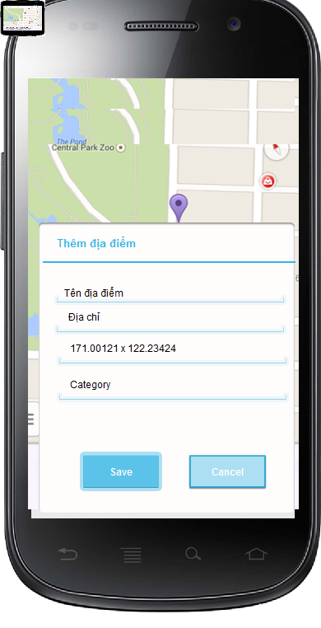

### Search result on Map

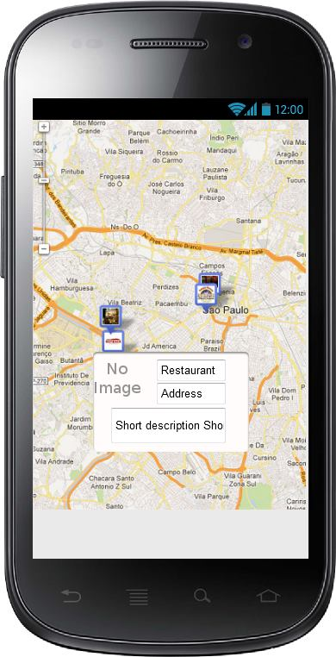

### Information of Place



### List Place Images

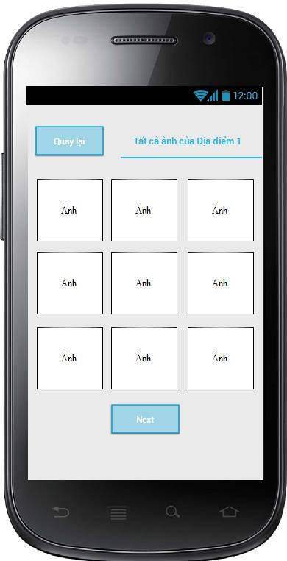

### Edit user information



## Database Design

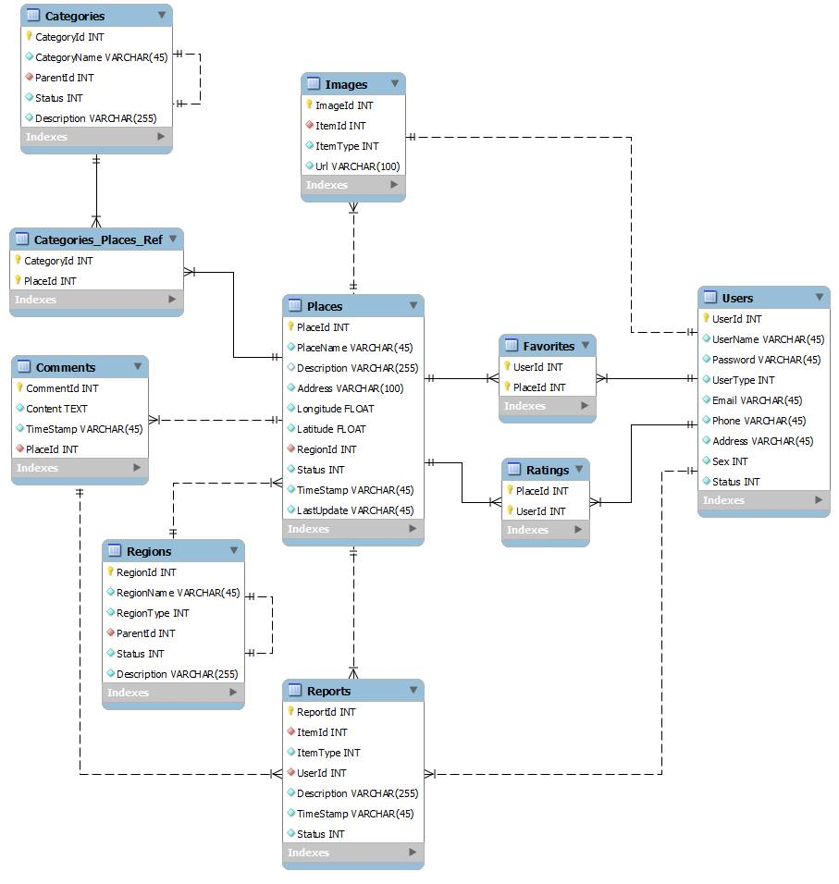

# System Implementation & Test (SIT)

## Introduction

### Overview

This testing approach document is designed for Capstone project – Splace Application of S-team. The document contains an overview of the testing activities to be performed when an upgrade or enhancement is made, or a module is added to an existing application. The emphasis is on testing critical business processes, while minimizing the time necessary for testing while also mitigating risks. It’s important to note that reducing the amount of testing done in an upgrade increases the potential for problems after go-live. Management will need to determine how much risk is acceptable on an upgrade by upgrade basis.

#### Purpose of Testing

Testing ensures that the system still meets the requirement needs (functional and non-functional requirements). The intent of System Test is to find defects and correct them before go-live. There is no approach or method to guarantee a system completely free of defects. However, following a System Test approach will assist in mitigating risks and ensuring a successful project.

Important testing goals include:

* Identify and publish the scope and substance of the testing effort (test case coverage report).
* Identify and publish risks to the successful completion of the project.
* Verify functional correctness (critical path must work).
* Report on the status of the product regarding the tests and measures (weekly status reports).
* Confirm consistency in design and implementation within the application.
* Confirm consistency with standards in other applications.
* Test product robustness and stability.

### Test Approach

Using V-Model to implement testing process

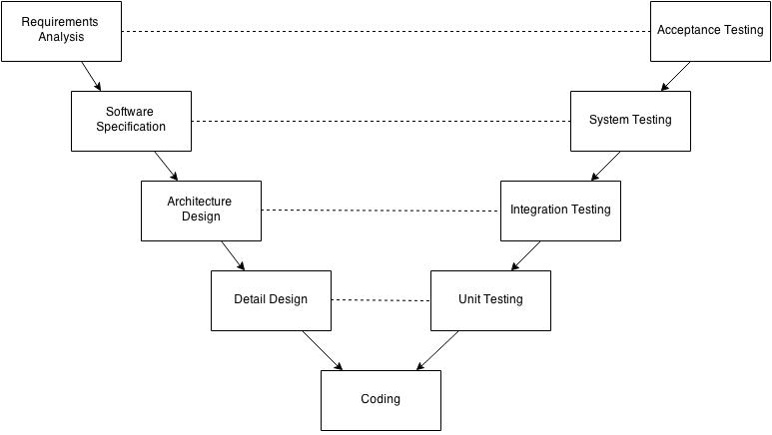

Figure 5‑1 : Testing and Developing with V-Model

With V-Model, software development is separated into two appropriate phases‘ groups: development and testing. Testing phase is carried out simultaneously from the early of project, the requirement specification phase. Therefore, tester could study and understand the entire requirement as well as business of project

Moreover, there are many variations among planning, design and implementation during the whole project. To catch up with all changes and ensure logic as well as business model is chose as a solution to help testers control and follow the actual workflows.

This testing is executed to ensure that all requirements mentioned in SRS, included both functional requirements and non-functional requirements which are implemented correctly.

The project will have three levels of testing : Unit, System/Integration and Qualification/Acceptance . The details for each level are addressed in the approach section and will be further defined in the level specific plans.

#### Unit testing

Unit Testing will be done by the developer and will be approved by the development team leader. Proof of unit testing (test case list, sample output, data printouts, defects information) must be provided by the programmer to the team leader before unit testing will be accepted and passed on to the test person. All unit test information will also be provided to the test person.

#### Integration Testing

Integration Testing will be performed by both test person and developer after unit testing to ensure that application is working after building individual units. The purpose of this level of testing is to expose faults in the interaction between integrated units.

#### System testing

System Testing will be performed by the test manager and development team leader with assistance from the individual developers as required. No specific test tools are available for this project. Programs will enter into System test after all critical defects have been corrected. A program may have up to two Major defects as long as they do not impede testing of the program (I.E. there is a work around for the error).

**For each Phase of System Testing:**

1. Execute the test condition.
2. Check the output against the expected results.
3. Evaluate and document any unexpected results. Utilize testing incidents database.
4. Make sure that any required corrections are migrated and re-tested.
5. Make sure that final testing components (conditions, input, and expected results) are accurate, complete and documented in such a way to make them repeatable and reusable.
6. Review and obtain Acknowledgment of System Test results where appropriate (i.e. new functionality).

#### Acceptance testing

Acceptance Testing will be performed by the all of Test team and Development team, stand at end user point of view. The acceptance test will be done for a period of 1 week after completion of the System/Integration test process.

Programs will enter into Acceptance test after all critical and major defects have been corrected. A program may have one major defect as long as it does not impede testing of the program (I.E. there is a work around for the error). Prior to final completion of acceptance testing all open critical and major defects MUST be corrected and verified by the Test manager and Development team leader.

## Test plan

### Features to be tested

#### Android Application

* Login / Logout
* Forgot password
* Edit Account Information
* View Place
* Search Place
* View Place’s Information
* Direction
* Add place
* Comment / Delete comment
* Rating
* Report
* Add to Favorite
* View Favorite Place
* Remove Favorite Place

#### Website Backend

* Manage Registered User
* Statistics of system
* Review Place
* Review Report
* Review Comment
* Review Account
* Review Category

### Feature not to be tested

* **Security** : The security of this version is not be ensured
* **Performance**: There wasn’t enough time so we can’t optimize source code and improve performance. We can only ensure the system work well but not at its best performance.
* **Overload** : There wasn’t enough time for us build a large database system to test overload of application so we only can ensure the system work well with relatively amount database.
* **Screen resolution :** The display of application will be tested only on LG F180L with screen size 4.7 inches & Google Nexus 4 with screen size 4.7 inches.

### Testing tools and environment

#### Hardware

The product needs to be tested in some hardware devices:

Android Smartphone (Nexus 4, LG F180L)

The product will NOT be tested in Android Tablet device.

#### Software

In addition to the application and any other user specified software, the following list of software should be considered a minimum:

* Microsoft Office Excel 2010
* Microsoft Office Work 2010

#### Operating Systems

The product will be tested in:

* Microsoft Windows 7, 8.
* Ubuntu
* Android 4.0 and greater.

## Test Case

### Unit Test

#### Android Application

|  |  |  |  |  |  |
| --- | --- | --- | --- | --- | --- |
| **ID** | **Class** | **Method** | **Test result 1** | **Test result 2** | **Done by** |
| 1 | UserFunctions | resetPassword(List<NameValuePair> params) | Pass |  | VuongTX |
| 2 | UserFunctions | signUp(List<NameValuePair> params) | Pass |  | VuongTX |
| 3 | UserFunctions | getCategory() | Pass |  | VuongTX |
| 4 | UserFunctions | signOut(List<NameValuePair> params) | Pass |  | VuongTX |
| 5 | UserFunctions | getUser(List<NameValuePair> params) | Pass |  | VuongTX |
| 6 | UserFunctions | setFavorite(List<NameValuePair> params) | Pass |  | VuongTX |
| 7 | UserFunctions | getFavorite() | Pass |  | VuongTX |
| 8 | UserFunctions | setPlace(List<NameValuePair> params) | Pass |  | VuongTX |
| 9 | UserFunctions | getPlace(String placeID) | Pass |  | VuongTX |
| 10 | UserFunctions | editUser(List<NameValuePair> params) | Pass |  | VuongTX |
| 11 | UserFunctions | addFavorite(List<NameValuePair> params) | Pass |  | VuongTX |
| 12 | UserFunctions | removeFavorite(List<NameValuePair> params) | Pass |  | VuongTX |
| 13 | UserFunctions | getComment(String placeID) | Pass |  | VuongTX |
| 14 | UserFunctions | loginUser(List<NameValuePair> params,Activity contextParent) | Pass |  | VuongTX |
| 15 | UserFunctions | resetPassword(List<NameValuePair> params) | Pass |  | VuongTX |
| 16 | UserFunctions | addPlace(List<NameValuePair> params) | Pass |  | VuongTX |
| 17 | UserFunctions | addComment(List<NameValuePair> params) | Pass |  | VuongTX |
| 18 | UserFunctions | getComment(String placeId) | Pass |  | VuongTX |
| 19 | UserFunctions | searchPlace(List<NameValuePair> params) | Pass |  | VuongTX |
| 20 | UserFunctions | signUp(List<NameValuePair> params,Activity contextParent) | Pass |  | VuongTX |
| 21 | UserFunctions | getFavorite(int userID) | Pass |  | VuongTX |
| 22 | UserFunctions | getUser(int userID) | Pass |  | VuongTX |
| 23 | UserFunctions | getPlace(int placeID) | Pass |  | VuongTX |
| 24 | DataAccess | insertUser(User user) | Pass |  | VuongTX |
| 25 | DataAccess | updateUser(User u) | Pass |  | VuongTX |
| 26 | DataAccess | removeInUse(int id) | Pass |  | VuongTX |
| 27 | DataAccess | getUserInUse() | Pass |  | VuongTX |
|  |  |  |  |  |  |

#### Website backend

|  |  |  |  |  |  |
| --- | --- | --- | --- | --- | --- |
| **ID** | **Class** | **Method** | **Test Result 1** | **Test Result 2** | **Done by** |
| 1 | User | resetPassword(List<NameValuePair> params) | Pass |  | TuanVA |
| 2 | User | check_username($username) | Pass |  | TuanVA |
| 3 | User | check_email($email) | Pass |  | TuanVA |
| 4 | User | post_addUser()  $temp = Input::only('email','password','repassword'); | Pass |  | TuanVA |
| 5 | User | login()  Input::only('email', 'password') | Pass |  | TuanVA |
| 6 | User | logout() | Pass |  | TuanVA |
| 7 | User | viewUser($id) | Pass |  | TuanVA |
| 8 | User | editUser($id) | Pass |  | TuanVA |
| 9 | User | deleteUser($userid) | Pass |  | TuanVA |
| 10 |  |  | Pass |  | TuanVA |
| 11 | Place | post_addPlace()  Input::only('placename', 'description', 'address', 'longitude', 'latitude', 'regionid') | Pass |  | TuanVA |
| 12 | Place | searchPlace()  Input::only('placename', 'categoryid', 'regionid'); | Pass |  | TuanVA |
| 13 | Place | listPlace($page = 1) | Pass |  | TuanVA |
| 14 | Place | viewPlace($id) | Pass |  | TuanVA |
| 15 | Place | editPlace($id) | Pass |  | TuanVA |
| 16 | Place | deletePlace($placeid) | Pass |  | TuanVA |
| 17 | Categories | addCategory() | Pass |  | TuanVA |
| 18 | Categories | post_addCategory()  Input::only('categoryname', 'parentid', 'description') | Pass |  | TuanVA |
| 19 | Categories | getCategory($id = 0) | Pass |  | TuanVA |
| 20 | Categories | deleteCategory($categoryid) | Pass |  | TuanVA |
| 21 | Categories | editCategory($id) | Pass |  | TuanVA |
| 22 | Categories | post_editCategory()  Input::only('categoryid','categoryname', 'parentid', 'description'); | Pass |  | TuanVA |
| 23 | Region | addRegion() | Pass |  | TuanVA |
| 24 | Region | post_addRegion()  Input::only('regionname', 'regiontype', 'parentid','description') | Pass |  | TuanVA |
| 25 | Region | getRegion($id = 0) | Pass |  | TuanVA |
| 26 | Region | editRegion($id) | Pass |  | TuanVA |
| 27 | Region | deleteRegion($id) | Pass |  | TuanVA |
| 28 | Region | post_editRegion() | Pass |  | TuanVA |
| 29 | Comment | post_addComment()  Input::only('content', 'placeid') | Pass |  | TuanVA |
| 30 | Comment | post_addReport()  Input::only('itemId','itemType','description') | Pass |  | TuanVA |
| 31 | Report | post_addReport()  Input::only('itemId','itemType','description') | Pass |  | TuanVA |
| 32 | Report | getReport($id = 0) | Pass |  | TuanVA |
| 33 | Favorite | post_addFavorite()  Input::only('placeid') | Pass |  | TuanVA |
| 34 | Favorite | getFavorite($id = 0) | Pass |  | TuanVA |
| 35 | CmsHelper | Detectapp() | Pass |  | TuanVA |

### Integration Test

#### Website & Web service

|  |  |  |  |  |  |  |  |  |
| --- | --- | --- | --- | --- | --- | --- | --- | --- |
| **ID** | **Test Case Description** | | **Test Case Procedure** | **Expected Output** | **Result 1** | **Result 2** | | **Note** |
| **Login function on website** | | | | | | | | |
| Step :   * Enter website at : <http://cogidau.com> by computer internet browser | | | | | | | | |
| 1 | | Login Succesful | **Valid account**  1. Input correctly email (username) and password into email and password field.  2. Click [Đăng nhập] button. | Administrator backend opened | Pass |  | |  |
| 2 | | Login fail | **Blank Account**  1. Do not input username and password  2. Click [Đăng nhập] button | Failed login notification appeared, Administrator backend is not opened | Pass |  | |  |
|  | | **Blank username**  1. Input password, do not input username  2. Click [Đăng nhập] button | Pass |  | |  |
|  | | **Blank password**  1. Input username, do not input password  2. Click [Đăng nhập] button | Pass |  | |  |
|  | | **Invalid username**  1. Input wrong user name and password  2. Click [Đăng nhập] button | Pass |  | |  |
|  | | **Invalid password**  1. Input correct username and wrong password  2. Click [Đăng nhập] button | Failed login notification appeared, Administrator backend is not opened | Pass |  | |  |
|  | | **Invalid permission**  1. Input username and password of a non-administrator account  2. Click [Đăng nhập] button | Pass |  | |  |
| **Administrator function on website** | | | | | | | | |
| Step: - Logged in website backend with correct username & password of administrator  - Click section “User” | | | | | | | | |
| Test View All User | | | | | | | | |
| 1 | | Test function “User” | Click “User” or login Successful | Show all user | Pass |  | |  |
| 2 | | Test hyperlink “Edit” | Click hyperlink “Edit” | “Edit” form is displayed | Pass |  | |  |
| 3 | | Test hyper link “Delete” form | Click hyperlink “delete” | Show message  “User đã được xóa thành công” | Fail |  | | Delete lỗi |
| **Test Edit account** | | | | | | | | |
| Step : - Logged in website backend with correct username & password of administrator  - Click section “user”  - Click hyperlink “Edit” at the next screen | | | | | | | | |
| 1 | | Test hyperlink “edit” | Click hyperlink “edit” | The “Edit user” form is displayed account | Pass |  | |  |
| 2 | | Test “edit” form | 1.Don’t edit to whatever from “edit” form  2. Click “save user” button | Show message “Cập nhật bị lỗi!” | Pass |  | |  |
| 3 | | Test textbox “userID” | Write to textbox | Can’t write to “userID” | Pass |  | |  |
| 4 | | Test textbox  “email” | 1.Edit textbox email from “[tuanva@nghich.vn](mailto:tuanva@nghich.vn)” to “hunguq”  2. Click “save user” button | Show message “Email không hợp lệ, vui long nhập lại” | Pass |  | |  |
| 5 | | Test textbox  “email” | 1. Edit textbox email from “[tuanva@nghich.vn](mailto:tuanva@nghich.vn)” to “hunguq@gmail”  2. Click “save user” button | Show message “Email không hợp lệ, vui long nhập lại” | Pass |  | |  |
| 6 | | Test textbox  “email” | 1.Clear textbox “email”  2. Click “save user” button | Show message “Email không hợp lệ, vui long nhập lại” | Pass |  | |  |
| 7 | | Test textbox  “email” | 1. Edit textbox “email” from “[tuanva@nghich.vn](mailto:tuanva@nghich.vn)” to “hunguq@gmail.com”  2. Click “save user” button | Show message “Cập nhật thành công!” | Pass |  | |  |
| 8 | | Test textbox  “Username” | 1.Clear textbox “UserName”  2. Click “save user” button | Show message “Cập nhật thành công!” | Pass |  | |  |
| 9 | | Test textbox  “Username” | 1. Edit textbox “UserName”l from “voanhtuan” to “hunguq”  2. Click “save user” button | Show message “Cập nhật thành công!” | Pass |  | |  |
| 10 | | Test textbox  “Address” | 1.Clear textbox “Address”  2. Click “save user” button | Show message “Cập nhật thành công!” | Pass |  | |  |
| 11 | | Test textbox  “Address” | 1. Edit textbox “Address”l from “ong” to “hochiminh”  2. Click “save user” button | Show message “Cập nhật thành công!” | Pass |  | |  |
| 12 | | Test textbox  “Phone” | 1.Clear textbox “Phone”  2. Click “save user” button | Show message “Cập nhật thành công!” | Pass |  | |  |
| 13 | | Test textbox  “Phone” | 1. Edit textbox “Phone”l from “098888888” to “01682305618”  2. Click “save user” button | Show message “Cập nhật thành công!” | Pass |  | |  |
| 14 | | Test combobox  “sex” | 1. Edit combobox “Sex”l from “mail” to “femail”  2. Click “save user” button | Show message “Cập nhật thành công!” | Pass |  | |  |
| 15 | | Test combobox  “sex” | 1. Edit combobox “Sex”l from “femail” to “unknow”  2. Click “save user” button | Show message “Cập nhật thành công!” | Pass |  | |  |
| 16 | | Test combobox  “sex” | 1.Don’t change whatever from Combobox “sex”  2. Click “save user” button | Show message “Cập nhật bị lỗi!” | Pass |  | |  |
| 17 | | Test hyperlink  “[Go back home!](http://cogidau.com/)” | Click hyperlink “[Go back home!](http://cogidau.com/)” | Administrator backend opened | Pass |  | |  |
| **Manage place on website** | | | | | | | | |
| Step: - Logged in website backend with correct username & password of administrator  - Click section“Place” | | | | | | | | |
| **Test view “Place”** | | | | | | | | |
| 1 | | Test form “Place” | Click “Place” | Show All Place | Pass |  |  | |
| 2 | | Test hyperlink “Edit” | Click Hyperlink “Edit” | “Edit” form is displayed |  |  |  | |
| 3 | | Test hyperlink “Delete” | Click hyperlink “Delete” | Show message  “Place đã được xóa thành công” | Pass |  |  | |
| 4 | | Test buton “Add new place” | Click button “Add new place” | “Add new place” form is displayed | Pass |  |  | |
| **Test “Add new place”**  **Step:**  - Logged in website backend with correct username & password of administrator  - Click section “Place”  - Click button “Add new place” at the next screen | | | | | | | | |
| 1 | | Test “Add new place” button | Click button “Add new place” | The “Add new place” form is displayed | Pass |  |  | |
| 2 | | Test textbox  “Place Name” | Clear textbox “Place Name” | Show message “  PlaceName không thể để trống, vui lòng nhập lại” | Pass |  | Chỉnh sửa để thông báo khi nhập đúng hoặc nhập sai ngay sau khi nhập xong textbox | |
| 3 | | Test textbox  “Place Name” | Write “sen” | Place name is accepted | Pass |  |  | |
| 4 | | Test textbox  “Description” | Clear textbox “Description” | Description is accepted | Pass |  |  | |
| 5 | | Test textbox  “Description” | Write “dep va sang trong” | Description is accepted | Pass |  |  | |
| 6 | | Test textbox  “Address” | Clear textbox “Address” | Show message  “Address không được để trống, vui lòng nhập lại” | Pass |  |  | |
| 7 | | Test textbox  “Address | Write “ho guom” | Address is accepted | Pass |  |  | |
| 8 | | Test textbox  “Longitude” | Clear textbox “Longitude” | Longitude is accepted | Pass |  |  | |
| 9 | | Test textbox  “Longitude” | Write “192” | Longitude is accepted | Pass |  |  | |
| 10 | | Test textbox  “**Latitude**” | Clear textbox “**Latitude**” | Latitude is accepted | Pass |  |  | |
| 11 | | Test textbox  “**Latitude**” | Write “192” | Latitude is accepted | Pass |  |  | |
| 12 | | Test combobox “**Category**” | Select “Select Category” | Category is accepted | Pass |  |  | |
| 13 | | Test combobox “**Region”** | Select “Select Region” | Region is accepted | Pass |  |  | |
| 14 | | Test “Submit” button | Click button “Submit” | - Show message “Place đã được thêm thành công”  - The “Place” form is displayed | Pass |  |  | |
| **Test Edit place**  **Step:**  - Logged in website backend with correct username & password of administrator  - Click section “Place”  - Click hyperlink “Edit” at the next screen | | | | | | | | |
| 1 | | Test hyper link “Edit” | Click hyperlink “Edit” | -The “Edit place” form is displayed | Pass |  |  | |
| 2 | | Test textbox “PlaceID” | 1-Edit value from textbox“PlaceID” | -Can’t edit textbox “PlaceID” | Pass |  |  | |
| 3 | | Test form “edit Place” | 1.Don’t edit to whatever from “edit” form  2. Click “save user” button | -Show message “Cập nhật bị lỗi!” | Fail |  |  | |
| 4 | | Test textbox “Description” | 1-Clear textbox “Description”  2-Click “save place” button | -Show message “Cập nhật bị lỗi!” | Fail |  | Đổi tên button save user | |
| 5 | | Test textbox “Description” | 1-Edit textbox “Description”l from “dep” to “sang trong”  2-Click “save place” button | -Show message “Cập nhật bị lỗi!” | Fail |  |  | |
| 6 | | Test textbox “**Address**” | 1-Clear textbox “Address”  2-Click “save place” button | Show message “Address không thể để trống, vui lòng nhập” | Fail |  |  | |
| 7 | | Test textbox “**Address**” | 1-Edit textbox “Address”l from “Hotay” to “Tay Ho”  2-Click “save place” button | -Show message “Cập nhật thành công!” | Fail |  |  | |
| 8 | | Test textbox “**Longitude**” | 1-Clear textbox “**Longitude**”  2-Click “save place” button | -Show message “Cập nhật thành công!” | Fail |  |  | |
| 9 | | Test textbox “**Longitude**” | 1-Edit textbox “**Longitude**”l from “105.819 ” to “123”  2-Click “save place” button | -Show message “Cập nhật thành công!” | Fail |  |  | |
| 10 | | Test textbox “**Latitude**” | 1-Clear textbox “**Latitude**”  2-Click “save place” button | -Show message “Cập nhật thành công!” | Fail |  |  | |
| 11 | | Test textbox “**Latitude**” | 1-Edit textbox “**Latitude**”l from “21.0508 to “24”  2-Click “save place” button | -Show message “Cập nhật thành công!” | Fail |  |  | |
| 12 | | Test combobox “**Region**” | 1-Edit textbox “**Region**”l from “21.0508 to “24”  2-Click “save place” button | -Show message “Cập nhật thành công!” | Fail |  |  | |
| 13 | | Test combobox “**Region**” | 1-Edit textbox “**Region**”l from “21.0508 to “24”  2-Click “save place” button | -Show message “Cập nhật thành công!” | Fail |  |  | |
| 14 | | Test hyperlink “go back home!” | Click hyperlink “go back home!” | -Administrator backend opened | Pass |  |  | |
| **Manage comment on website** | | | | | | | | |
| Step: - Logged in website backend with correct username & password of administrator  - Click section “Comment” | | | | | | | | |
| Test View all comment | | | | | | | | |
| 1 | | Test form “Comment” | Click “comment” | -Show all Comments of users | Pass |  |  | |
| 2 | | Test hyperlink “Delete” | Click hyperlink “delete” | - Show message  “Comment đã được xóa thành công” | Pass |  |  | |
| **Manage Category on website** | | | | | | | | |
| Step: - Logged in website backend with correct username & password of administrator  - Click section “Category” | | | | | | | | |
| **Test “Category” view all** | | | | | | | | |
| 1 | | Test form “Category” | Click “category” | -Show all category | Pass |  |  | |
| 2 | | Test hyperlink “Edit” | Click hyperlink “Edit” | “Edit” form is displayed | Pass |  |  | |
| 3 | | Test hyperlink “Delete” | Click hyperlink “delete” | -Show message “Category đã được xóa thành công” | Pass |  |  | |
| 4 | | Test button “Add new category” | Click button “Add new category” | “Category” form is displayed | Pass |  |  | |
| **Test “Add new category”**  Step:  - Logged in website backend with correct username & password of administrator  - Click section “Category”  **-** Click button “Add new category” | | | | | | | | |
| 1 | | Test button “add new category” | Click button “add new category” | -The “Add new category” form is displayed | Pass |  |  | |
| 2 | | Test textbox “category name” | Clear textbox “category name” | -Show message “Category name không thể để trống, vui lòng nhập lại” | Pass |  |  | |
| 3 | | Test textbox “category name” | Write “an” | -Show message “Category Name phải 6 kí tự trở lên, vui lòng nhập lại” | Pass |  |  | |
| 4 | | Test textbox “category name” | Write “vui choi” | Category name is accepted | Pass |  |  | |
| 5 | | Test textbox “**Description**” | Clear textbox “**Description**” | Description name is accepted | Pass |  |  | |
| 6 | | Test textbox “**Description**” | Write “dong vui nhon nhip” | Description name is accepted | Pass |  |  | |
| 7 | | Test button “**Submit**” | -Click button “Submit” | -Show message “Category mới đã được thêm thành công”  -The “category” form is display | Fail |  | Chưa thông báo add thành công | |
| **Test “Edit category”**  Step:  - Logged in website backend with correct username & password of administrator  - Click section “Category”  **-** Click hyperlink “Edit” | | | | | | | | |
| 1 | | Test hyper link “edit” | -Click hyperlink “edit” | -The “category edit” form is display | Pass |  |  | |
| 2 | | Test “edit” form | -Don’t change whatever in Edit form | Show message “Update Fail” |  |  |  | |
| 3 | | Test textbox “CategoryID” | 1-Edit value from textbox“PlaceID” | Can’t edit value from textbox “PlaceID” | Fail |  | Vẫn edit bình thường, nhưng k update đc, lỗi | |
| 4 | | Test textbox “CategoryName” | 1-Clear textbox “category name”  2-Click “save category” button | Show message “Category name không thể để trống, vui lòng nhập lại” | Fail |  | Clear vẫn up date đc | |
| 5 | | Test textbox “CategoryName” | 1-Edit textbox “Category name”form “an uong” to “an”  2-Click “save category” button | -Show message “Category Name phải 6 kí tự trở lên, vui lòng nhập lại” | Fail |  | Ít hơn 6 vẫn update được | |
| 6 | | Test textbox “CategoryName” | 1-Edit textbox “Category name”form “an uong” to “vui choi nhay mua”  2-Click “save category” button | -Show message “Category được cập nhật thành công” | Pass |  |  | |
| 7 | | Test textbox “Description” | 1-Clear textbox “description”  2-Click “save category” button | -Show message “Category được cập nhật thành công” | Pass |  |  | |
| 8 | | Test textbox “Description” | 1-Edit textbox “Description”form “vui ve” to “buon chan” | -Show message “Category được cập nhật thành công” | Pass |  |  | |
| 9 | | Test hyperlink “go back home!” | Click hyperlink “go back home!” | -Administrator backend opened | Fail |  | Chưa có hyperlink này | |
| **Manage Report on website Backend** | | | | | | | | |
| Step: - Logged in website backend with correct username & password of administrator  - Click Section “Report” | | | | | | | | |
| **Test “Report” View all** | | | | | | | | |
| **1** | | Test function “Report” | Click section “Report” | Show all Report | Pass |  |  | |
| **2** | | Test hyperlink“Edit” | Click hyperlink “Edit” | Form “Edit report” form is displayed | Fail |  | **Không ra cái gì** | |
| **3** | | Test hyperlink “Delete” | Click hyperlink “Delete” | - Show message “Report đã được xóa thành công!” | Fail |  | **Lỗi** | |
| **Manage Region on website Backend** | | | | | | | | |
| Step: - Logged in website backend with correct username & password of administrator  - Click section“Region” | | | | | | | | |
| **Test “Region” View all** | | | | | | | | |
| 1 | | Test function “Region” | Click “Region” | -Show all Region | Pass |  |  | |
| 2 | | Test button “Add new region” | Click button “Add new region” | -Form “Add new region” form is displayed | Pass |  |  | |
| 3 | | Test hyperlink“Edit” | Click hyperlink “Edit” | -Form “Edit region” form is displayed | Pass |  |  | |
| 4 | | Test hyperlink “Delete” | Click hyperlink “Delete” | - Show message “Region had been deleted!” | Pass |  |  | |
| **Test Add new region**  Step: - Logged in website backend with correct username & password of administrator  - Click section“Region”  - Click button “Add new Region” | | | | | | | | |
| 1 | | Test textbox “RegionName” | -Clear textbox “Region name” | -Show message “Region name không thể để trống, Vui lòng nhập lại” | Pass |  |  | |
| 2 | | Test textbox “RegionName” | -Wrire “ab” | -Show message “Region Name phải 3 kí tự trở lên” | pass |  |  | |
| 3 | | Test textbox “RegionName” | -Write “Long bien” | RegionName is accepted | Pass |  |  | |
| 4 | | Test textbox “Description” | -Clear textbox “Description” | Description is accepted | Pass |  |  | |
| 5 | | Test textbox “Description” | -Write “trung tâm” | Description is accepted | Pass |  |  | |
| 6 | | Test textbox “RegionType” | -Clear textbox “RegionType” | -Show message “Region type không thể để trống, vui lòng nhập lại” | fail |  | K nhập gì vẫn được nhưng không add được | |
| 7 | | Test textbox “RegionType” | -Write “1” | RegionType is accepted | Pass |  |  | |
| 8 | | Test button “submit” | -Click button “submit” | -Show message “Region mới đã được thêm thành công”  -Region webform is displayed | Fail |  | Chưa có thông báo add thành công | |
| **Test Edit Region**  Step: - Logged in website backend with correct username & password of administrator  - Click section “Region”  - Click hyperlink “Edit” | | | | | | | | |
| 1 | | Test textbox “Region ID” | -Edit value in textbox “RegionID” | -Can’t change value textbox “regionID” | Fail |  | Vẫn thay đổi được | |
| 2 | | Test form “Edit” | -Don’t change everything in “EditRegion” form | -Show message “Cập nhật bị lỗi” | Pass |  |  | |
| 3 | | Test textbox “RegionName” | -Clear textbox “Region name”  -Click button “Save region” | -Show message “Region name không thể để trống, Vui lòng nhập lại” | Fail |  | Chưa có thông báo không nhập | |
| 4 | | Test textbox “RegionName” | -Edit textbox “RegionName” from “Longbien” to “av”  -Click button “Save region” | -Show message “Region Name phải 3 kí tự trở lên, vui lòng nhập lại” | Fail |  | Chưa có thông báo không nhập | |
| 5 | | Test textbox “RegionName” | -Edit textbox “RegionName” from “Longbien” to “Hoan Kiem”  -Click button “Save region” | -Show message “RegionName đã được cập nhật” | pass |  |  | |
| 6 | | Test textbox “Description | -Clear textbox “Description”  -Click button “Save region” | -Show message “RegionName đã được cập nhật” | Pass |  |  | |
| 7 | | Test textbox “Description” | -Edit textbox “RegionName” from “” to “quận trung tâm”  -Click button “Save region” | -Show message “RegionName đã được cập nhật” | Pass |  |  | |
| 8 | | Test textbox “RegionType” | -Clear textbox “Region type”  -Click button “Save region” | -Show message “Region type không thể để trống, vui lòng nhập lại” | Pass |  | Vẫn update được, ra type = 0 | |
| 9 | | Test textbox “Regiontype” | -Edit textbox “Regiontype” from “1” to “2”  -Click button “Save region” | -Show message “RegionType đã được cập nhật” | Pass |  |  | |
| 11 | | Test hyperlink “go back home!” | -Click hyperlink “go back home” | Administrator backend opened | Fail |  | Chưa có hyper link | |
| **Test Function Logout**  Step: - Logged in website backend with correct username & password of administrator | | | | | | | | |
| 1 | | Test Function “Logout” | Click section “logout” | -Account is logouted  -Login form is displayed | Pass |  |  | |

#### Android Application & Webservice

|  |  |  |  |  |  |  |  |  |  |  |  |  |
| --- | --- | --- | --- | --- | --- | --- | --- | --- | --- | --- | --- | --- |
| **ID** | **Test Case Description** | | **Test Case Procedure** | | **Expected Output** | | **Test Result 1** | | **Test Result 2** | | **Note** | |
| **Login function on Android Application** | | | | | | | | | | | |
| Step :   * Open SPlace Application on Android smartphone | | | | | | | | | | | |
| 1 | Login Succesful | **Valid account**  1. Input correctly email (username) and password into email and password field.  2. Click [Đăng nhập] button. | | Display loading Screen, after check login successful, Search Place screen opened. | | Fail | | Pass | |  | |
| 2 | Login fail | **Blank Account**  1. Do not input username and password  2. Click [Đăng nhập] button | | Display loading Screen, after check login, display login screen again and Failed login notification appeared | | Fail | | Pass | |  | |
|  | **Blank username**  1. Input password, do not input username  2. Click [Đăng nhập] button | | Fail | | Pass | |  | |
|  | **Blank password**  1. Input username, do not input password  2. Click [Đăng nhập] button | | Fail | | Pass | |  | |
|  | **Invalid username**  1. Input wrong user name and password  2. Click [Đăng nhập] button | | Fail | | Pass | |  | |
|  | **Invalid password**  1. Input correct username and wrong password  2. Click [Đăng nhập] button | | Display loading Screen, after check login, display login screen again and Failed login notification appeared | | Fail | | Pass | |  | |
| **Register User function on Android app** | | | | | | | | | | | |
| Step : - Open Application   - Click on Text [Chưa có tài khoản, đăng ký tại đây] | | | | | | | | | | | |
|  | Display register screen | **Register form display** 1. Open Application  2. Click on Text [Chưa có tài khoản, đăng ký tại đây] | | Register user form displayed | | Pass | |  | |  | |
|  | Registered success | **Valid information**  1. Input valid email and password & confirm password.  2. Check box [ tôi đồng ý các điều khoản sử dụng] is checked.  3. Click button [Đăng ký] | | - Display message “Đăng ký thành công” | | Pass | |  | |  | |
|  | Register Failed | **Email used already** 1. Input an used email and password & confirm password.  2. Check box [ tôi đồng ý các điều khoản sử dụng] is checked.  3. Click button [Đăng ký] | | Registered failed. | | Pass | |  | |  | |
|  | **Invalid Email** 1. Input an invalid email to email field and password & confirm password.  2. Check box [ tôi đồng ý các điều khoản sử dụng] is checked.  3. Click button [Đăng ký] | | Registered failed. | | Pass | |  | |  | |
|  | **Different between password and confirm password** 1. Input an email and password & another string to confirm password.  2. Check box [ tôi đồng ý các điều khoản sử dụng] is checked.  3. Click button [Đăng ký] | | Registered failed. | | Pass | |  | |  | |
|  | **Blank email**  1. Input an password & confirm password.  2. Check box [ tôi đồng ý các điều khoản sử dụng] is checked.  3. Click button [Đăng ký] | | Registered failed. | | Pass | |  | |  | |
|  | **Blank password**  1. Input an Email & confirm password.  2. Check box [ tôi đồng ý các điều khoản sử dụng] is checked.  3. Click button [Đăng ký] | | Registered failed. | | Pass | |  | |  | |
|  | **Blank confirm password**  1. Input an Email & password. Do not input confirm password  2. Check box [ tôi đồng ý các điều khoản sử dụng] is checked.  3. Click button [Đăng ký] | | Registered failed. | | Pass | |  | |  | |
|  | **Blank all input fields**  1. Do not input anythings  2. Check box [ tôi đồng ý các điều khoản sử dụng] is checked.  3. Click button [Đăng ký] | | Registered failed. | | Pass | |  | |  | |
|  | **Check box is not checked**  1. Input valid email and password & confirm password.  2. Don’t check the Check box [ tôi đồng ý các điều khoản sử dụng]   3. Click button [Đăng ký] | | Registered failed. | | Pass | |  | |  | |
|  | Register Failed | **No network connection** 1. Input valid email and password & confirm password.  2. Check the check box [Tôi đồng ý các điều khoản sử dụng] 3. Click button [Đăng ký] | | Registered failed. | | Fail | |  | |  | |
| **Log out function on Android Application** | | | | | | | | | | | |
| Step : - Logged in with correct username and password | | | | | | | | | | | |
|  | Log out | **Log out  -** Click menu or press menu button. - Select log out menu from menu list. | | Logout successfully. | | Pass | |  | |  | |
| **Comment place on Android Application** | | | | | | | | | | | |
| Step : - Open android application  - Logged with correct username and password.  - View a place information. | | | | | | | | | | | |
|  | Comment failed | **Blank comment input  -** Do not input anything on comment field. - Press enter on keyboard or “Gửi bình luận” button. | | Comment failed. | | Pass | |  | |  | |
|  | **Comment is too long -** Input a text with length > 1000 chars on comment field.  - Press enter on keyboard or “Gửi bình luận” button. | | Comment failed | | Fail | |  | |  | |
|  | **No network connection**  **-**Input comment to comment field  - Press enter on keyboard or “Gửi bình luận” button. | | Comment failed. | | Pass | |  | |  | |
|  | **Comment is too short.**  **-** Input a text with length <3 char on comment field.  - Press enter on keyboard or “Gửi bình luận” button. | | Comment failed | | Fail | |  | |  | |
|  | Comment success | **Input UTF 8 character ( Vietnamese)** - Input Vietnamese into comment field, for example : “Test bình luận”  -Press Enter on keyboard or “Gửi Bình luận” button | | Comment success.  Display comment correctly. | | Fail | |  | | The comment has been display correctly. | |
|  | Comment success | **Input English Character  -** Input English comment into comment field, for example : “Test comment function” -Press Enter on virtual keyboard or tap on “gửi bình luận” | | Comment success. Display comment correctly | | Pass | |  | |  | |
|  |  | **Clear Comment field after comment success**  **-** Input comment into comment field.  -Press Enter on virtual keyboard or tap on “gửi bình luận”  - Wait for the comment display on comment section.  -Check the comment input field | | Comment input field is cleared | | Fail | |  | |  | |
| **Search Place simple** | | | | | | | | | | | |
| **Step :** - Open Application.  - Tap on “Tìm địa điểm” button. | | | | | | | | | | | |
|  |  | **Blank input -** Do not input anything into search field.  -Do not change category select box.  -Click button search | | Display message : “bạn cần nhập tên địa điểm cần tìm hoặc chọn danh mục” | | Fail. | |  | | Displayed all place, doesn’t have message. | |
|  |  | **Blank place name -**Do not input anything into search field.  -Select 1 category from category drop down list.  - Press button : “Tìm địa điểm” | | Display all place on this category. Display place sign on map. | | Fail | |  | | Displayed all place, not sort by category | |
|  |  | **Search with place name. -**Input a place name that existed in database. -Select category that this place belong to. | | Display search result with this place. | | Pass | |  | |  | |
|  |  | **Search with place name but wrong category.**  **-**Input a place name that existed in database  - Press button : “Tìm địa điểm” | | Display the result that match the criteria. If not, display no result. | | Pass | |  | |  | |
|  |  | **Vietnamese input in Place name.** -Input a Vietnamese place name that existed in database. - Select “Tất cả” from Category.  - Press button : “Tìm địa điểm” | | Display the result that match the criteria. | | Fail | |  | | Cant search with place name is Vietnamese. | |
|  |  | **English input in Place name -**Input a English name, or Vietnamese name without utf 8 that existed in database. - Select “Tất cả” from Category. - Press Button : “tìm địa điểm” | | Display result that match the criteria. | | Pass | |  | |  | |
| **Search place - Advanced** | | | | | | | | | | | |
| **Step :** - Open Application.  - Login with correct username and password.  - Open user menu or click to menu button of phone.  - Choose option : “tìm kiếm theo phạm vi” | | | | | | | | | | | |
|  |  | **Defaut input** - Don’t change the radius at combo box  - Tap the location that you want to search around. | | Display place result with mark in map. Searching area will be marked by a circle | | Pass | |  | |  | |
|  |  | **Different radius**  **-**Change the radius at combo box  - Retap to screen to select location that you want to search around. | | Display different result that match the criteria. Search area circle will also change | | Pass | |  | |  | |
| **Add new place** | | | | | | | | | | | |
| Step : - Open Application.  - Login with correct username and password.  - Open user menu or click to menu button of phone, then select : “Thêm địa điểm” | | | | | | | | | | | |
|  |  | **Blank input :**  -Do not input anything into place name, don’t touch at map.  - Click “Gửi” button. | | Add failed. Display message : “Bạn cần nhập đủ thông tin” | | Fail. | |  | | Add fail but display common message :”Xảy ra lỗi, vui lòng thử lại sau” | |
|  |  | **Blank place name -** Leave place name blank, fill all of these others with correct data. - Touch on map to get location information. - Click “Gửi” button. | | Add failed. Display message : “Bạn cần nhập tên địa điểm” | | Fail. | |  | | Add fail but display common message :”Xảy ra lỗi, vui lòng thử lại sau” | |
|  |  | **Blank address -** Leave place address blank, fill all of these others with correct data.  - Touch on map to get location information. - Click “Gửi” button. | | Add failed. Display message : “Bạn cần nhập địa chỉ của địa điểm” | | fail | |  | | Add fail but display common message :”Xảy ra lỗi, vui lòng thử lại sau” | |
|  |  | **Lack of coordinates**  **-** Fill all fields with correct data.  - Don’t touch on map to get location information. - Click “Gửi” button. | | Add failed. Display message : “Bạn phải chọn vị trí cho địa điểm trên bản đồ” | | Fail | |  | | Place is still added. | |
|  |  | **Blank Description -** Leave place description blank, fill all of these others with correct data. - Touch on map to get location information. - Click “Gửi” button. | | Add successful. | | Pass | |  | |  | |
|  |  | **Correct input -**Fill all field with correct data. - Touch on map to get location information. - Click button “Gửi” | | Add successfull | | Pass | |  | |  | |
| **User profile function** | | | | | | | | | | | |
| Step : - Open Application.  - Login with correct username and password.  - Open user menu or click to menu button of phone, then select : “thông tin tài khoản” | | | | | | | | | | | |
|  |  | **Display user profile screen**  - Open Application. - Login with correct username and password. - Open user menu or click to menu button of phone, then select : “thông tin tài khoản” | | User profile screen displayed with text field and hint correctly | | Fail | |  | |  | |
|  |  |  | |  | |  | |  | |  | |
|  |  |  | |  | |  | |  | |  | |
|  |  |  | |  | |  | |  | |  | |
|  |  |  | |  | |  | |  | |  | |
|  |  |  | |  | |  | |  | |  | |
|  |  |  | |  | |  | |  | |  | |
|  |  |  | |  | |  | |  | |  | |
|  |  |  | |  | |  | |  | |  | |
|  |  |  | |  | |  | |  | |  | |
|  |  |  | |  | |  | |  | |  | |
| **Favorite Function.** | | | | | | | | | | | |
| Step : - Open Application.  - Login with correct username and password.  - Search for a place and enter place detail. | | | | | | | | | | | |
|  | Add to favorite | -Tap on “thêm vào danh sách yêu thích” button. | | Button disappear on click. Place is added to favorite list | | Pass | |  | |  | |
|  | View Favorite List | - Open user menu or click to menu button of phone, then select : “Địa chỉ yêu thích” | | Display list of favorite Place | | Pass | |  | |  | |
|  | Display Favorite Place | -Tap on a place on favorite list | | Display this place detail. | | Pass | |  | |  | |
| **Rating Function.** | | | | | | | | | | | |
| Step : - Open Application.  - Login with correct username and password.  - Search for a place and enter place detail. | | | | | | | | | | | |
|  | Rate a place | **-**Tap on stars for rating. | | Stars disappears on tap. Number of rating increase. | | Pass | |  | |  | |
| **Logout function**  Step : - Open Application.  - Login with correct username and password. | | | | | | | | | | | |
|  |  | - Open user menu or click to menu button of phone, then select : “Đăng xuất” | | User is logged out. Return to login screen | | Pass | |  | |  | |

### System test

#### Website Backend

|  |  |  |  |  |  |  |
| --- | --- | --- | --- | --- | --- | --- |
| **ID** | | **Test Case Procedure** | **Expected Output** | **Result** 1 | **Result 2** | **Done by** |
| **Login function on website** | | | | | | |
| Step :   * Enter website at : <http://cogidau.com> by computer internet browser | | | | | | |
| 1 | **Valid account**  1. Input correctly email (username) and password into email and password field.  2. Click [Đăng nhập] button. | | Administrator backend opened | Pass |  |  |
| 2 | **Blank Account**  1. Do not input username and password  2. Click [Đăng nhập] button | | Failed login notification appeared, Administrator backend is not opened | Pass |  |  |
|  | **Blank username**  1. Input password, do not input username  2. Click [Đăng nhập] button | | Pass |  |  |
|  | **Blank password**  1. Input username, do not input password  2. Click [Đăng nhập] button | | Pass |  |  |
|  | **Invalid username**  1. Input wrong user name and password  2. Click [Đăng nhập] button | | Pass |  |  |
|  | **Invalid password**  1. Input correct username and wrong password  2. Click [Đăng nhập] button | | Failed login notification appeared, Administrator backend is not opened | Pass |  |  |
|  | **Invalid permission**  1. Input username and password of a non-administrator account  2. Click [Đăng nhập] button | | Pass |  |  |
| **Administrator function on website** | | | | | | |
| Step: - Logged in website backend with correct username & password of administrator  - Click section “User” | | | | | | |
| Test View All User | | | | | | |
| 1 | Click “User” or login Successful | | Show all user | Pass |  |  |
| 2 | Click hyperlink “Edit” | | “Edit” form is displayed | Pass |  |  |
| 3 | Click hyperlink “delete” | | Show message  “User đã được xóa thành công” | Fail |  |  |
| **Test Edit account** | | | | | | |
| Step : - Logged in website backend with correct username & password of administrator  - Click section “user”  - Click hyperlink “Edit” at the next screen | | | | | | |
| 1 | Click hyperlink “edit” | | The “Edit user” form is displayed account | Pass |  |  |
| 2 | 1.Don’t edit to whatever from “edit” form  2. Click “save user” button | | Show message “Cập nhật bị lỗi!” | Pass |  |  |
| 3 | Write to textbox | | Can’t write to “userID” | Pass |  |  |
| 4 | 1.Edit textbox email from “[tuanva@nghich.vn](mailto:tuanva@nghich.vn)” to “hunguq”  2. Click “save user” button | | Show message “Email không hợp lệ, vui long nhập lại” | Pass |  |  |
| 5 | 1. Edit textbox email from “[tuanva@nghich.vn](mailto:tuanva@nghich.vn)” to “hunguq@gmail”  2. Click “save user” button | | Show message “Email không hợp lệ, vui long nhập lại” | Pass |  |  |
| 6 | 1.Clear textbox “email”  2. Click “save user” button | | Show message “Email không hợp lệ, vui long nhập lại” | Pass |  |  |
| 7 | 1. Edit textbox “email” from “[tuanva@nghich.vn](mailto:tuanva@nghich.vn)” to “hunguq@gmail.com”  2. Click “save user” button | | Show message “Cập nhật thành công!” | Pass |  |  |
| 8 | 1.Clear textbox “UserName”  2. Click “save user” button | | Show message “Cập nhật thành công!” | Pass |  |  |
| 9 | 1. Edit textbox “UserName”l from “voanhtuan” to “hunguq”  2. Click “save user” button | | Show message “Cập nhật thành công!” | Pass |  |  |
| 10 | 1.Clear textbox “Address”  2. Click “save user” button | | Show message “Cập nhật thành công!” | Pass |  |  |
| 11 | 1. Edit textbox “Address”l from “ong” to “hochiminh”  2. Click “save user” button | | Show message “Cập nhật thành công!” | Pass |  |  |
| 12 | 1.Clear textbox “Phone”  2. Click “save user” button | | Show message “Cập nhật thành công!” | Pass |  |  |
| 13 | 1. Edit textbox “Phone”l from “098888888” to “01682305618”  2. Click “save user” button | | Show message “Cập nhật thành công!” | Pass |  |  |
| 14 | 1. Edit combobox “Sex”l from “mail” to “femail”  2. Click “save user” button | | Show message “Cập nhật thành công!” | Pass |  |  |
| 15 | 1. Edit combobox “Sex”l from “femail” to “unknow”  2. Click “save user” button | | Show message “Cập nhật thành công!” | Pass |  |  |
| 16 | 1.Don’t change whatever from Combobox “sex”  2. Click “save user” button | | Show message “Cập nhật bị lỗi!” | Pass |  |  |
| 17 | Click hyperlink “[Go back home!](http://cogidau.com/)” | | Administrator backend opened | Pass |  |  |
| **Manage place on website** | | | | | | |
| Step: - Logged in website backend with correct username & password of administrator  - Click section“Place” | | | | | | |
| **Test view “Place”** | | | | | | |
| 1 | Click “Place” | | Show All Place | Pass |  |  |
| 2 | Click Hyperlink “Edit” | | “Edit” form is displayed |  |  |  |
| 3 | Click hyperlink “Delete” | | Show message  “Place đã được xóa thành công” | Pass |  |  |
| 4 | Click button “Add new place” | | “Add new place” form is displayed | Pass |  |  |
| **Test “Add new place”**  **Step:**  - Logged in website backend with correct username & password of administrator  - Click section “Place”  - Click button “Add new place” at the next screen | | | | | | |
| 1 | Click button “Add new place” | | The “Add new place” form is displayed | Pass |  |  |
| 2 | Clear textbox “Place Name” | | Show message “  PlaceName không thể để trống, vui lòng nhập lại” | Pass |  |  |
| 3 | Write “sen” | | Place name is accepted | Pass |  |  |
| 4 | Clear textbox “Description” | | Description is accepted | Pass |  |  |
| 5 | Write “dep va sang trong” | | Description is accepted | Pass |  |  |
| 6 | Clear textbox “Address” | | Show message  “Address không được để trống, vui lòng nhập lại” | Pass |  |  |
| 7 | Write “ho guom” | | Address is accepted | Pass |  |  |
| 8 | Clear textbox “Longitude” | | Longitude is accepted | Pass |  |  |
| 9 | Write “192” | | Longitude is accepted | Pass |  |  |
| 10 | Clear textbox “**Latitude**” | | Latitude is accepted | Pass |  |  |
| 11 | Write “192” | | Latitude is accepted | Pass |  |  |
| 12 | Select “Select Category” | | Category is accepted | Pass |  |  |
| 13 | Select “Select Region” | | Region is accepted | Pass |  |  |
| 14 | Click button “Submit” | | - Show message “Place đã được thêm thành công”  - The “Place” form is displayed | Pass |  |  |
| **Test Edit place**  **Step:**  - Logged in website backend with correct username & password of administrator  - Click section “Place”  - Click hyperlink “Edit” at the next screen | | | | | | |
| 1 | Click hyperlink “Edit” | | -The “Edit place” form is displayed | Pass |  |  |
| 2 | 1-Edit value from textbox“PlaceID” | | -Can’t edit textbox “PlaceID” | Pass |  |  |
| 3 | 1.Don’t edit to whatever from “edit” form  2. Click “save user” button | | -Show message “Cập nhật bị lỗi!” | Fail |  |  |
| 4 | 1-Clear textbox “Description”  2-Click “save place” button | | -Show message “Cập nhật bị lỗi!” | Fail |  |  |
| 5 | 1-Edit textbox “Description”l from “dep” to “sang trong”  2-Click “save place” button | | -Show message “Cập nhật bị lỗi!” | Fail |  |  |
| 6 | 1-Clear textbox “Address”  2-Click “save place” button | | Show message “Address không thể để trống, vui lòng nhập” | Fail |  |  |
| 7 | 1-Edit textbox “Address”l from “Hotay” to “Tay Ho”  2-Click “save place” button | | -Show message “Cập nhật thành công!” | Fail |  |  |
| 8 | 1-Clear textbox “**Longitude**”  2-Click “save place” button | | -Show message “Cập nhật thành công!” | Fail |  |  |
| 9 | 1-Edit textbox “**Longitude**”l from “105.819 ” to “123”  2-Click “save place” button | | -Show message “Cập nhật thành công!” | Fail |  |  |
| 10 | 1-Clear textbox “**Latitude**”  2-Click “save place” button | | -Show message “Cập nhật thành công!” | Fail |  |  |
| 11 | 1-Edit textbox “**Latitude**”l from “21.0508 to “24”  2-Click “save place” button | | -Show message “Cập nhật thành công!” | Fail |  |  |
| 12 | 1-Edit textbox “**Region**”l from “21.0508 to “24”  2-Click “save place” button | | -Show message “Cập nhật thành công!” | Fail |  |  |
| 13 | 1-Edit textbox “**Region**”l from “21.0508 to “24”  2-Click “save place” button | | -Show message “Cập nhật thành công!” | Fail |  |  |
| 14 | Click hyperlink “go back home!” | | -Administrator backend opened | Pass |  |  |
| **Manage comment on website** | | | | | | |
| Step: - Logged in website backend with correct username & password of administrator  - Click section “Comment” | | | | | | |
| Test View all comment | | | | | | |
| 1 | Click “comment” | | -Show all Comments of users | Pass |  |  |
| 2 | Click hyperlink “delete” | | - Show message  “Comment đã được xóa thành công” | Pass |  |  |
| **Manage Category on website** | | | | | | |
| Step: - Logged in website backend with correct username & password of administrator  - Click section “Category” | | | | | | |
| **Test “Category” view all** | | | | | | |
| 1 | Click “category” | | -Show all category | Pass |  |  |
| 2 | Click hyperlink “Edit” | | “Edit” form is displayed | Pass |  |  |
| 3 | Click hyperlink “delete” | | -Show message “Category đã được xóa thành công” | Pass |  |  |
| 4 | Click button “Add new category” | | “Category” form is displayed | Pass |  |  |
| **Test “Add new category”**  Step:  - Logged in website backend with correct username & password of administrator  - Click section “Category”  **-** Click button “Add new category” | | | | | | |
| 1 | Click button “add new category” | | -The “Add new category” form is displayed | Pass |  |  |
| 2 | Clear textbox “category name” | | -Show message “Category name không thể để trống, vui lòng nhập lại” | Pass |  |  |
| 3 | Write “an” | | -Show message “Category Name phải 6 kí tự trở lên, vui lòng nhập lại” | Pass |  |  |
| 4 | Write “vui choi” | | Category name is accepted | Pass |  |  |
| 5 | Clear textbox “**Description**” | | Description name is accepted | Pass |  |  |
| 6 | Write “dong vui nhon nhip” | | Description name is accepted | Pass |  |  |
| 7 | -Click button “Submit” | | -Show message “Category mới đã được thêm thành công”  -The “category” form is display | Fail |  |  |
| **Test “Edit category”**  Step:  - Logged in website backend with correct username & password of administrator  - Click section “Category”  **-** Click hyperlink “Edit” | | | | | | |
| 1 | -Click hyperlink “edit” | | -The “category edit” form is display | Pass |  |  |
| 2 | -Don’t change whatever in Edit form | | Show message “Update Fail” |  |  |  |
| 3 | 1-Edit value from textbox“PlaceID” | | Can’t edit value from textbox “PlaceID” | Fail |  |  |
| 4 | 1-Clear textbox “category name”  2-Click “save category” button | | Show message “Category name không thể để trống, vui lòng nhập lại” | Fail |  |  |
| 5 | 1-Edit textbox “Category name”form “an uong” to “an”  2-Click “save category” button | | -Show message “Category Name phải 6 kí tự trở lên, vui lòng nhập lại” | Fail |  |  |
| 6 | 1-Edit textbox “Category name”form “an uong” to “vui choi nhay mua”  2-Click “save category” button | | -Show message “Category được cập nhật thành công” | Pass |  |  |
| 7 | 1-Clear textbox “description”  2-Click “save category” button | | -Show message “Category được cập nhật thành công” | Pass |  |  |
| 8 | 1-Edit textbox “Description”form “vui ve” to “buon chan” | | -Show message “Category được cập nhật thành công” | Pass |  |  |
| 9 | Click hyperlink “go back home!” | | -Administrator backend opened | Fail |  |  |
| **Manage Report on website Backend** | | | | | | |
| Step: - Logged in website backend with correct username & password of administrator  - Click Section “Report” | | | | | | |
| **Test “Report” View all** | | | | | | |
| **1** | Click section “Report” | | Show all Report | Pass |  |  |
| **2** | Click hyperlink “Edit” | | Form “Edit report” form is displayed | Fail |  |  |
| **3** | Click hyperlink “Delete” | | - Show message “Report đã được xóa thành công!” | Fail |  |  |
| **Manage Region on website Backend** | | | | | | |
| Step: - Logged in website backend with correct username & password of administrator  - Click section“Region” | | | | | | |
| **Test “Region” View all** | | | | | | |
| 1 | Click “Region” | | -Show all Region | Pass |  |  |
| 2 | Click button “Add new region” | | -Form “Add new region” form is displayed | Pass |  |  |
| 3 | Click hyperlink “Edit” | | -Form “Edit region” form is displayed | Pass |  |  |
| 4 | Click hyperlink “Delete” | | - Show message “Region had been deleted!” | Pass |  |  |
| **Test Add new region**  Step: - Logged in website backend with correct username & password of administrator  - Click section“Region”  - Click button “Add new Region” | | | | | | |
| 1 | -Clear textbox “Region name” | | -Show message “Region name không thể để trống, Vui lòng nhập lại” | Pass |  |  |
| 2 | -Wrire “ab” | | -Show message “Region Name phải 3 kí tự trở lên” | pass |  |  |
| 3 | -Write “Long bien” | | RegionName is accepted | Pass |  |  |
| 4 | -Clear textbox “Description” | | Description is accepted | Pass |  |  |
| 5 | -Write “trung tâm” | | Description is accepted | Pass |  |  |
| 6 | -Clear textbox “RegionType” | | -Show message “Region type không thể để trống, vui lòng nhập lại” | fail |  |  |
| 7 | -Write “1” | | RegionType is accepted | Pass |  |  |
| 8 | -Click button “submit” | | -Show message “Region mới đã được thêm thành công”  -Region webform is displayed | Fail |  |  |
| **Test Edit Region**  Step: - Logged in website backend with correct username & password of administrator  - Click section “Region”  - Click hyperlink “Edit” | | | | | | |
| 1 | -Edit value in textbox “RegionID” | | -Can’t change value textbox “regionID” | Fail |  |  |
| 2 | -Don’t change everything in “EditRegion” form | | -Show message “Cập nhật bị lỗi” | Pass |  |  |
| 3 | -Clear textbox “Region name”  -Click button “Save region” | | -Show message “Region name không thể để trống, Vui lòng nhập lại” | Fail |  |  |
| 4 | -Edit textbox “RegionName” from “Longbien” to “av”  -Click button “Save region” | | -Show message “Region Name phải 3 kí tự trở lên, vui lòng nhập lại” | Fail |  |  |
| 5 | -Edit textbox “RegionName” from “Longbien” to “Hoan Kiem”  -Click button “Save region” | | -Show message “RegionName đã được cập nhật” | pass |  |  |
| 6 | -Clear textbox “Description”  -Click button “Save region” | | -Show message “RegionName đã được cập nhật” | Pass |  |  |
| 7 | -Edit textbox “RegionName” from “” to “quận trung tâm”  -Click button “Save region” | | -Show message “RegionName đã được cập nhật” | Pass |  |  |
| 8 | -Clear textbox “Region type”  -Click button “Save region” | | -Show message “Region type không thể để trống, vui lòng nhập lại” | Pass |  |  |
| 9 | -Edit textbox “Regiontype” from “1” to “2”  -Click button “Save region” | | -Show message “RegionType đã được cập nhật” | Pass |  |  |
| 11 | -Click hyperlink “go back home” | | Administrator backend opened | Fail |  |  |
| Test Function Logout  Step: - Logged in website backend with correct username & password of administrator | | | | | | |
| 1 | Click section “logout” | | -Account is logouted  -Login form is displayed | Pass |  |  |

#### Android Application

|  |  |  |  |  |  |
| --- | --- | --- | --- | --- | --- |
| **ID** | **Test Case Procedure** | **Expected Output** | **Result** 1 | **Result 2** | **Done by** |
| **Login function on Android Application**  Step : Open SPlace Application on Android smartphone | | | | | |
|  | **Valid account**  1. Input correctly email (username) and password into email and password field.  2. Click [Đăng nhập] button. | Display loading Screen, after check login successful. Search Place screen opened. | Pass |  |  |
|  | **Blank Account**  1. Do not input username and password  2. Click [Đăng nhập] button | Display loading Screen, after check login, display login screen again and Failed login notification appeared  Display loading Screen, after check login, display login screen again and Failed login notification appeared | Pass |  |  |
|  | **Blank username**  1. Input password, do not input username  2. Click [Đăng nhập] button | Pass |  |  |
|  | **Blank password**  1. Input username, do not input password  2. Click [Đăng nhập] button | Pass |  |  |
|  | **Invalid username**  1. Input wrong user name and password  2. Click [Đăng nhập] button | Pass |  |  |
|  | **Invalid password**  1. Input correct username and wrong password  2. Click [Đăng nhập] button | Pass |  |  |
| **Register User function on Android app**  **Step** : - Open Application   - Click on Button [Đăng ký] | | | | | |
|  | **Register form display** 1. Open Application  2. Click on Text [Chưa có tài khoản, đăng ký tại đây] | Register user form displayed with 3 fields : **Email, mật khẩu & xác nhận mật khẩu**, check box “**Tôi đồng ý…”** & button “**Đăng ký**” | Pass |  |  |
|  | **Valid information**  1. Input valid email and password & confirm password.  2. Check box [ tôi đồng ý các điều khoản sử dụng] is checked.  3. Click button [Đăng ký] | Registered Successful  Display message “Đăng ký thành công”.  Redirect to simple search screen. | Pass |  |  |
|  | **Email used already** 1. Input an used email and password & confirm password.  2. Check box [ tôi đồng ý các điều khoản sử dụng] is checked.  3. Click button [Đăng ký] | Registered Failed  Display Message : “Email đã được sử dụng” | Pass |  |  |
|  | **Invalid Email** 1. Input an invalid email to email field and password & confirm password.  2. Check box [ tôi đồng ý các điều khoản sử dụng] is checked.  3. Click button [Đăng ký] | Registered Failed  Display Message : “Email không đúng” | Pass |  |  |
|  | **Different between password and confirm password** 1. Input an email and password & another string to confirm password.  2. Check box [ tôi đồng ý các điều khoản sử dụng] is checked.  3. Click button [Đăng ký] | Registered Failed  Display Message : “Nhắc lại mật khẩu không đúng” | Pass |  |  |
|  | **Blank email**  1. Input an password & confirm password.  2. Check box [ tôi đồng ý các điều khoản sử dụng] is checked.  3. Click button [Đăng ký] | Registered Failed  Display Message : “Email và mật khẩu không được để trống” | Pass |  |  |
|  | **Blank password**  1. Input an Email & confirm password.  2. Check box [ tôi đồng ý các điều khoản sử dụng] is checked.  3. Click button [Đăng ký] | Registered Failed  Display Message : “Email và mật khẩu không được để trống” | Pass |  |  |
|  | **Blank confirm password**  1. Input an Email & password. Do not input confirm password  2. Check box [ tôi đồng ý các điều khoản sử dụng] is checked.  3. Click button [Đăng ký] | Registered Failed  Display Message : “Email và mật khẩu không được để trống” | Pass |  |  |
|  | **Blank all input fields**  1. Do not input anythings  2. Check box [ tôi đồng ý các điều khoản sử dụng] is checked.  3. Click button [Đăng ký] | Registered Failed  Display Message : “Email và mật khẩu không được để trống” | Pass |  |  |
|  | **Check box is not checked**  1. Input valid email and password & confirm password.  2. Don’t check the Check box [ tôi đồng ý các điều khoản sử dụng]   3. Click button [Đăng ký] | Registered Failed  Display Message : “Bạn phải đồng ý với quy định sử dụng” | Pass |  |  |
|  | **No network connection** 1. Input valid email and password & confirm password.  2. Check the check box [Tôi đồng ý các điều khoản sử dụng] 3. Click button [Đăng ký]  4. Disable 3G and wifi connection. | Registered Failed  Display Message : “Lỗi kết nối mạng, kiểm tra lại kết nối wifi hay 3G” | Fail |  |  |
| **Log out function on Android Application**  Step :  - Open android application - Logged in with correct username and password | | | | | |
|  | **Log out  -** Click menu or press menu button. - Select log out menu from menu list. | Logout successful.  Return to login screen | Pass |  |  |
| **Comment place on Android Application**  Step : - Open android application  - Logged with correct username and password.  - View a place information. | | | | | |
|  | **Blank comment input  -** Do not input anything on comment field. - Press enter on keyboard or “Gửi bình luận” button. | Comment failed.  Display message : “Bạn phải nhập nội dung bình luận trước khi gửi” | Fail |  |  |
|  | **Comment is too long -** Input a text with length > 1000 chars on comment field.  - Press enter on keyboard or “Gửi bình luận” button. | Comment failed.  Display message “Nội dung bình luận không được dài hơn 1000 kí tự” | Fail |  |  |
|  | **No network connection**  **-**Input comment to comment field  - Press enter on keyboard or “Gửi bình luận” button. | Comment failed.  Display Message : “Lỗi kết nối mạng, kiểm tra lại kết nối wifi hay 3G” | Fail |  |  |
|  | **Comment is too short.**  **-** Input a text with length <3 char on comment field.  - Press enter on keyboard or “Gửi bình luận” button. | Comment failed.  Display message “Nội dung bình luận không được ngắn hơn 3 kí tự” | Fail |  |  |
|  | **Input UTF 8 character ( Vietnamese)** - Input Vietnamese into comment field, for example : “Test bình luận”  -Press Enter on keyboard or “Gửi Bình luận” button | Comment successful.  Comment display correctly | Pass |  |  |
|  | **Input English Character  -** Input English comment into comment field, for example : “Test comment function” -Press Enter on virtual keyboard or tap on “gửi bình luận” | Comment successful.  Comment display correctly | Pass |  |  |
|  | **Clear Comment field after comment success**  **-** Input comment into comment field.  -Press Enter on virtual keyboard or tap on “gửi bình luận”  - Wait for the comment display on comment section.  -Check the comment input field | Comment successful.  Comment field is cleared | Failed |  |  |
| **Search Place simple**  **Step :** - Open Application.  - Tap on “Tìm địa điểm” button. | | | | | |
|  | **Simple search screen display**  - Open Application.  - Tap on “Tìm địa điểm” button. | Simple search screen display with a text field ( hint : Tên địa điểm ), a dropdown list to select category, google map area & 2 button : Tìm kiếm & thêm địa điểm | Pass |  |  |
|  | **Blank input -** Do not input anything into search field.  -Do not change category select box.  -Click button search | Display all the place that existe in database, marked in map. | Pass |  |  |
|  | **Blank place name -**Do not input anything into search field.  -Select 1 category from category drop down list.  - Press button : “Tìm địa điểm” | Display all the place that existe in database that match the category criteria, marked in map. | Pass |  |  |
|  | **Search with place name. -**Input a place name that existed in database. -Select category that this place belong to. | Display the place that existe in database that match the name & category criteria, marked in map. | Pass |  |  |
|  | **Vietnamese input in Place name.** -Input a Vietnamese place name that existed in database. - Select “Tất cả” from Category.  - Press button : “Tìm địa điểm” | Display the place that match the name criteria. Search function work correctly, marked in map. | Pass |  |  |
|  | **English input in Place name -**Input a English name, or Vietnamese name without utf 8 that existed in database. - Select “Tất cả” from Category. - Press Button : “tìm địa điểm” | Display the place that match the name criteria. Search function work correctly, marked in map. | Pass |  |  |
| **Search place – Advanced**  **Step :** - Open Application.  - Login with correct username and password.  - Open user menu or click to menu button of phone.  - Choose option : “tìm kiếm theo phạm vi” | | | | | |
|  | **Advance search screen display**  - Open Application  - Login with correct username and password. - Open user menu or click to menu button of phone.  - Choose option : “tìm kiếm theo phạm vi” | Advanced search screen display with category dropdown list, google map area, radius dropdown list and “thêm địa điểm button” | Pass |  |  |
|  | **Defaut input** - Don’t change the radius at combo box  - Tap the location that you want to search around. | Display place result with mark in map. Searching area will be marked by a circle | Pass |  |  |
|  | **Different radius**  **-**Change the radius at combo box  - Retap to screen to select location that you want to search around. | Display different result that match the criteria. Search area circle will also change | Pass |  |  |
|  | **Button “thêm địa điểm” -**Tap on “Thêm địa điểm” button on this screen | Display add new place screen | Pass |  |  |
| **Add new place function**  Step : - Open Application.  - Login with correct username and password.  - Open user menu or click to menu button of phone, then select : “Thêm địa điểm” | | | | | |
|  | **Add new place display**  - Open Application. - Login with correct username and password. - Open user menu or click to menu button of phone, then select : “Thêm địa điểm” | Add new place screen display correctly with text fields : “Tên địa điểm”, “Địa chỉ”, “Latitude”, “longtitude”, “Description”, category Dropdown list, Region dropdown list, button “Gửi” & google map area | Pass |  |  |
|  | **Blank input :**  -Do not input anything into place name, don’t touch at map.  - Click “Gửi” button. | Add failed. Display message: “Bạn cần nhập đủ thông tin” | Pass |  |  |
|  | **Blank place name -** Leave place name blank, fill all of these others with correct data. - Touch on map to get location information. - Click “Gửi” button. | Add failed. Display message: “Bạn cần nhập tên địa điểm” | Pass |  |  |
|  | **Blank address -** Leave place address blank, fill all of these others with correct data.  - Touch on map to get location information. - Click “Gửi” button. | Add failed. Display message: “Bạn cần nhập địa chỉ của địa điểm” | Pass |  |  |
|  | **Lack of coordinates**  **-** Fill all fields with correct data.  - Don’t touch on map to get location information. - Click “Gửi” button. | Add failed. Display message: “Bạn phải chọn vị trí cho địa điểm trên bản đồ” | Pass |  |  |
|  | **Blank Description -** Leave place description blank, fill all of these others with correct data. - Touch on map to get location information. - Click “Gửi” button. | Add successful. | Pass |  |  |
|  | **Correct input -**Fill all field with correct data. - Touch on map to get location information. - Click button “Gửi” | Add successful. | Pass |  |  |
| **Favorite Function**  Step : - Open Application.  - Login with correct username and password.  - Search for a place and enter place detail. | | | | | |
|  | **Button “Thêm vào danh sách yêu thích” appear**  - Open Application.  - Login with correct username and password. - Search for a place and enter place detail.  - Verify that button “Thêm vào danh sách yêu thích” appear | Button “Thêm vào danh sách yêu thích” appear. | Pass |  |  |
|  | **Display Favorite list**  - Open user menu or click to menu button of phone, then select : “Địa chỉ yêu thích” | Display list of favorite Place | Pass |  |  |
|  | **Display favorite place detail**  - Open user menu or click to menu button of phone, then select : “Địa chỉ yêu thích”  -Tap on a place on favorite list | Display this place detail. | Pass |  |  |
| **Rating Function**  Step : - Open Application.  - Login with correct username and password.  - Search for a place and enter place detail. | | | | | |
|  | **Rating stars display** - Open Application. - Login with correct username and password. - Search for a place and enter place detail. | Rating stars displau | Pass |  |  |
|  | **Rating function**  - Open Application. - Login with correct username and password. - Search for a place and enter place detail.  **-**Tap on stars for rating. | Stars disappears on tap. Number of rating change (calculate by average ) | Fail |  | Number change at 1st time a place is rated, but when another rate, it doesn’t work. |
| **Logout function**  Step : - Open Application.  - Login with correct username and password. | | | | | |
|  | - Open user menu or click to menu button of phone, then select : “Đăng xuất” | User is logged out. Return to login screen | Pass |  |  |
| **Place detail Screen**  Step : - Open Application.  - Login with correct username and password.  - Search for a place and enter place detail. | | | | | |
|  | - Open Application. - Login with correct username and password. - Search for a place and enter place detail. | Place details screen is displayed with correct element : Place name,Rating start, Rating value, Report, Description, Address, Comment, “thêm vào danh sách yêu thích” button, “Bình luận” button, | Pass |  |  |
|  |  |  |  |  |  |

### Acceptance testing

## Checklists

### Checklist of validation :

|  |  |  |  |
| --- | --- | --- | --- |
| **Question** | **Yes** | **No** | **N/A** |
| 1. Does a failure of validation on every field cause a sensible user error message? |  | X |  |
| 2. Is the user required to fix entries which have failed validation tests? | x |  |  |
| 3. Have any fields got multiple validation rules and if so are all rules being applied? | x |  |  |
| 4. If the user enters an invalid value and touchs on the Save button (i.e. does not TAB off the field) is the invalid entry identified and highlighted correctly with an error message? |  | x |  |
| 5. Is validation consistently applied at screen level unless specifically required at field level? | x |  |  |
| 6. For all numeric fields check whether negative numbers can and should be able to be entered |  | X |  |
| 7. For all numeric fields check the minimum and maximum values and also some mid-range values allowable? |  | X |  |
| 8. For all character/alphanumeric fields check the field to ensure that there is a character limit specified and that this limit is exactly correct for the specified database size? |  | X |  |
| 9. Do all mandatory fields require user input? | x |  |  |
| 10. If any of the database columns don’t allow null values then the corresponding screen fields must be mandatory. (If any field, which initially was mandatory, has become optional then check whether null values are allowed in this field.) |  |  | x |

### Submission checklist

|  |  |  |  |
| --- | --- | --- | --- |
| **Question** | **Yes** | **No** | **N/A** |
| **Table and figure** | | | |
| Does every table column, including the stub column, have a heading? | x |  |  |
| Are all tables referred to in text? | x |  |  |
| Are the elements in the figures large enough to remain legible after the figure has been reduced to the width of a journal column or page? |  | X |  |
| Is lettering in a figure no smaller than 8 points and no larger than 14 points | x |  |  |
| Are the figures being submitted in a file format acceptable to the publisher? |  | X |  |
| Has the figure been prepared at a resolution sufficient to produce a high-quality image? |  |  | X |
| Are all figures numbered consecutively with Arabic numerals? |  | X |  |
| Are all figures and tables mentioned in the text and numbered in the order in which they are mentioned? | x |  |  |
| **Reference** | | | |
| Are references cited both in text and in the reference list? |  | X |  |
| Do the text citations and reference list entries agree both in spelling and in date? |  |  | x |
| Are journal titles in the reference list spelled out fully? |  | X |  |
| Are the references (both in the parenthetical text citations and in the reference list) ordered alphabetically by the authors’ surnames? |  | X |  |
| Are inclusive page numbers for all articles or chapters in books provided in the reference list? |  | X |  |
| Are references to studies included in your meta-analysis preceded by an asterisk? |  | X |  |
| **Format** | | | |
| Have you checked the journal’s website for instructions to authors regarding specific formatting requirements for submission? |  | x |  |
| Is the entire manuscript—including quotations, references, author note, content footnotes, and figure captions—double-spaced? Is the manuscript neatly prepared? |  |  | x |
| Are the margins at least 1 in. (2.54 cm)? | x |  |  |
| Arethe title pages, abstracts, references, appendices, content footnotes, tables, and figures on separate pages (with only one table or figure per page)? Are the figure captions on the same page as the figures? Are manuscript elements ordered in sequence, with the text pages between the abstract and the references? | x |  |  |
| Are all pages numbered in sequence, starting with the title page? | x |  |  |
| **Paragraphs and headings** | | | |
| Is each paragraph longer than a single sentence but not longer than one manuscript page? | x |  |  |
| Do the levels of headings accurately reflect the organization of the paper? |  |  | x |
| Do all headings of the same level appear in the same format? | x |  |  |

# System User’s Manual

## Installation Guide

### Application’s environmental require

The following software must be installed into android device (suggestion: Nexus5, LG LTE2, LG F180L…) support android version 4.0 and higher.

### Installing into Device

#### Download application from Android

#### Installing Application

After finishing downloading application, application will be automatically installed into device.

## User Guide

### Login/Register/Forgot Password Guide

After opening application, user will see login screen as below:

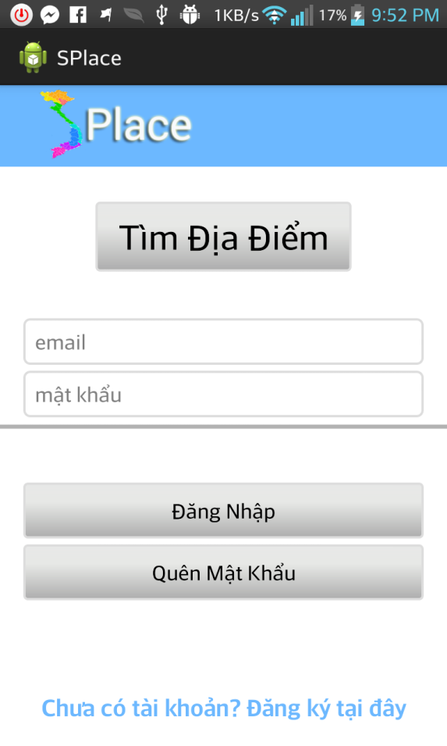

Figure 6‑1: Login Screen

To start using application enter Username and password, if don’t have account, please tap on “Chưa có tài khoản? Đăng ký tại đây” link to register an account.

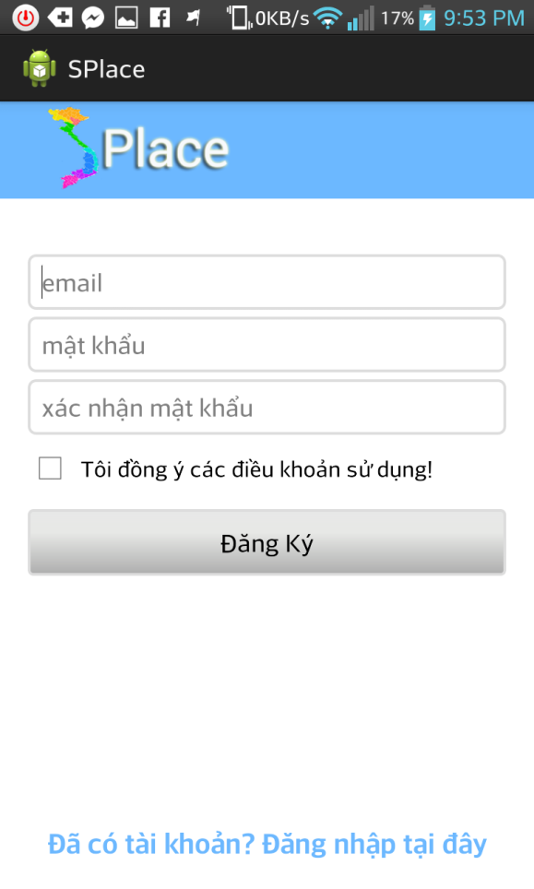

Figure 6‑2: Register Screen

In register screen, enter information into text field, check the check box and tap “Đăng Ký” button after finish filling information, be sure that device is connecting to Internet.

If you already have account but you forgot password, in login screen, tap “Quên Mật Khẩu” button to receive new password.

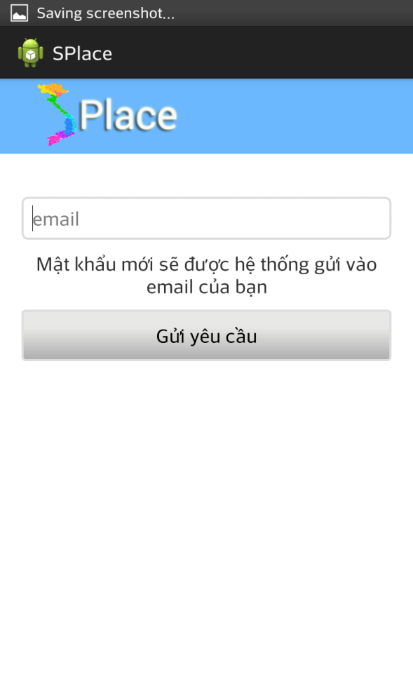

Figure 6‑3: Forgot Password Screen

In forgot password screen, enter your email and tap to “Gửi yêu cầu” button, system will send new password to your email.

### Application Guide

Application contains 4 main functions: Place, Account, Comment and Report function.

#### Place Function

After tap to “Tìm Địa Điểm” button or logged in, user will see search place screen.

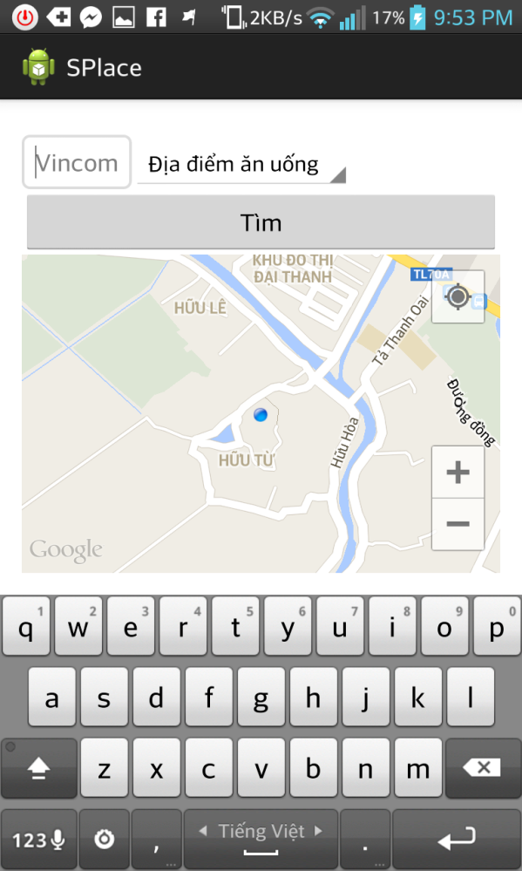

Figure 6‑4: Not Logged in’s Search Place Screen

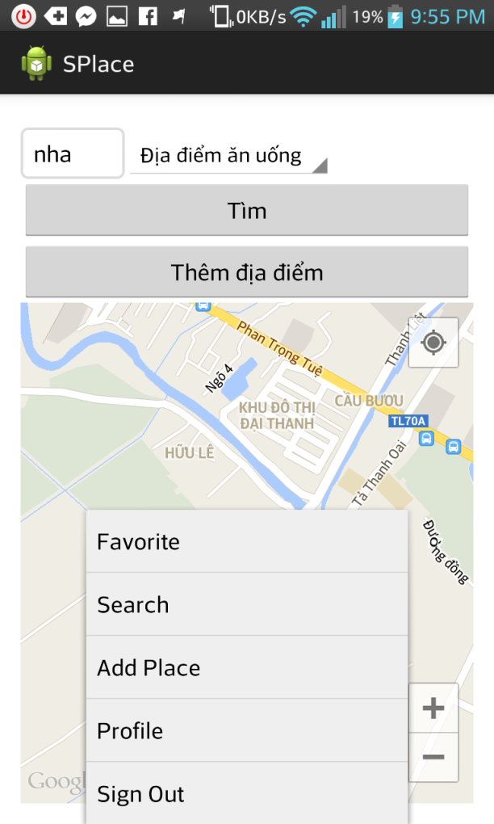

Figure 6‑5: Logged in’s Search Place Screen

##### Search Place

In search place screen, user fill name of place, choose category and click “Tìm” button.

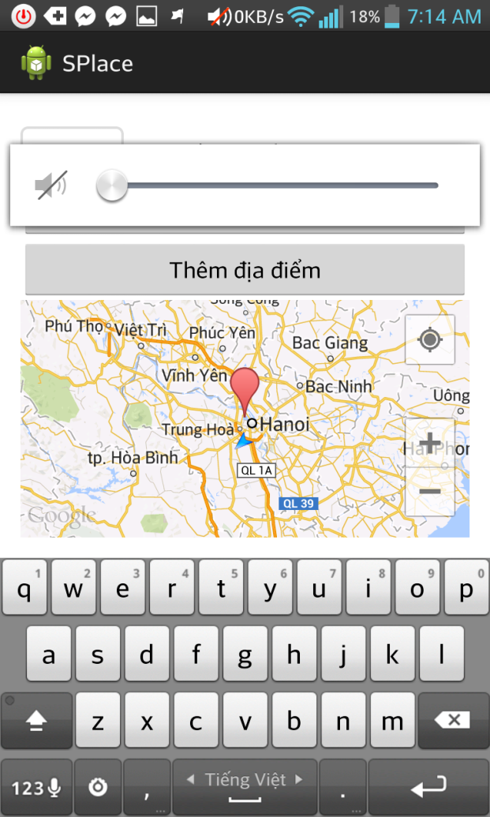

Figure 6‑6: Search Place Screen

##### View Place’s Information/Get Direction

User tap on flag on the map, system will show the place’s information screen

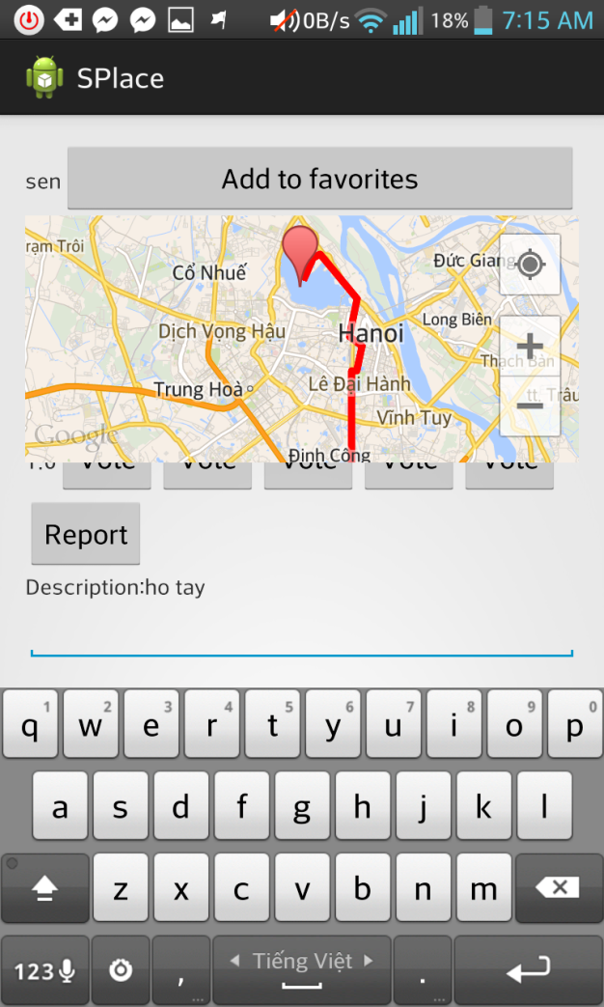

Figure 6‑7: Place’s Information Screen

In this screen, user can view information of place, rating, comment, report and add place to user’s favorite list.

##### Add Place

To add place, tap the menu button and choose “Thêm địa điểm”, add place screen will show.

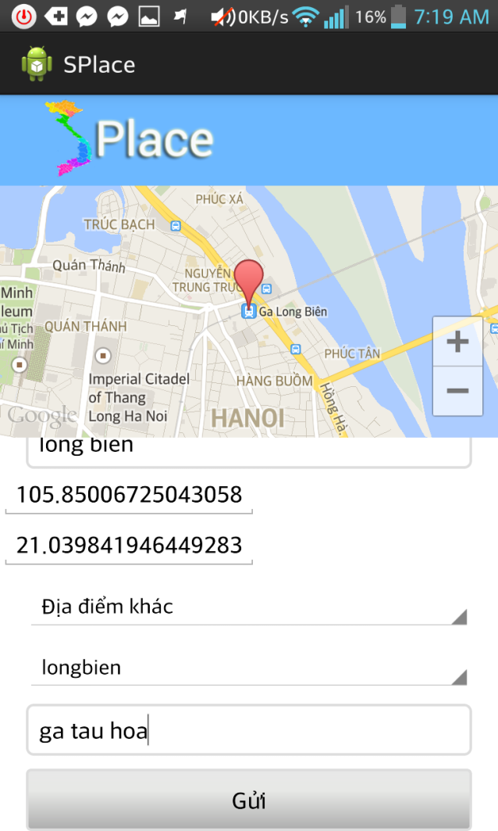

Figure 6‑8: Add Place Screen

After filling all information, tap to “Gửi” button, new place will be add to database but in pending status, this place must be reviewed by administrator before approve.

#### Account Function

To view and edit your account’s information, click menu button and tap to “Profile”. User will see the profile screen.

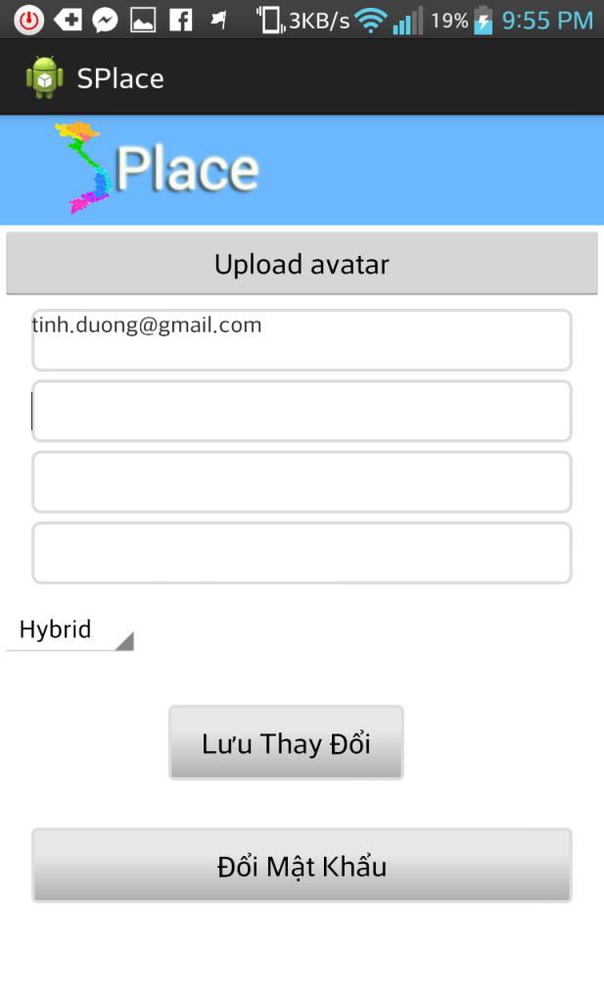

Figure 6-9: Profile Screen

In profile screen, click “Lưu Thay Đổi” button after editing your account’s information.

If you want to change your password, tap to “Đổi Mật Khẩu” Button.

Figure 6-10: Change Password Screen

#### Comment Function

In Place’s Information Screen, fill content and tap “Gửi bình luận” to comment.

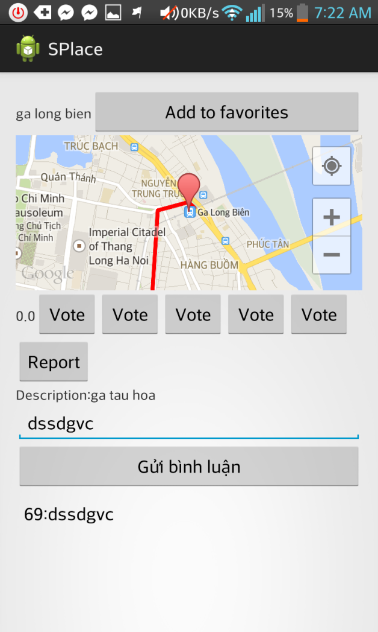

Figure 6-11: Comment

#### Report Function

##### Report Place

To report place, tap “Report” button on place’s information screen.

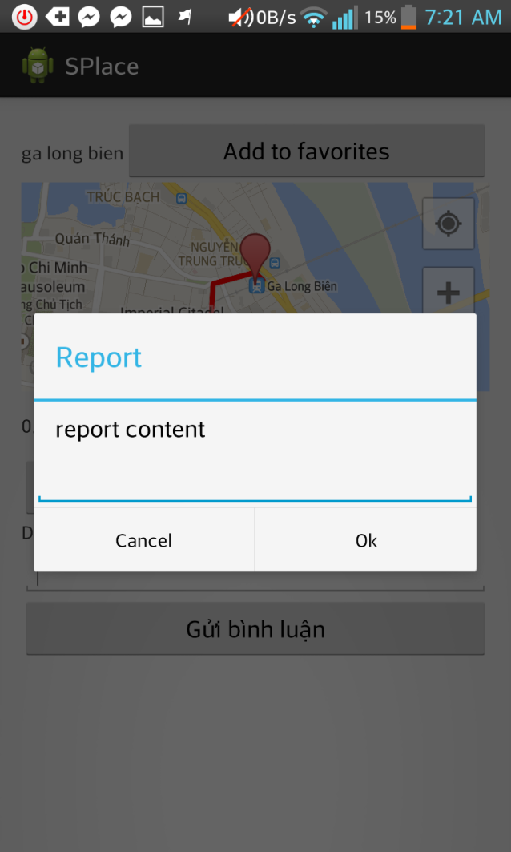

Figure 6-12: Report Place

Click “Ok” after filling content to send report to server.

##### Report Comment

Long tap to comment user want report, application will show a pop-up. Click “Report” to report this comment.

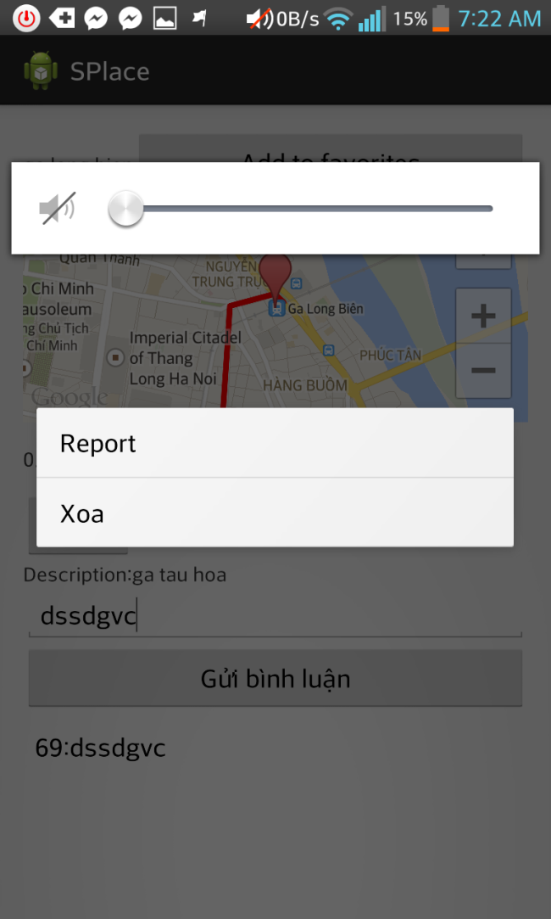

Figure 6-13: Pop-up

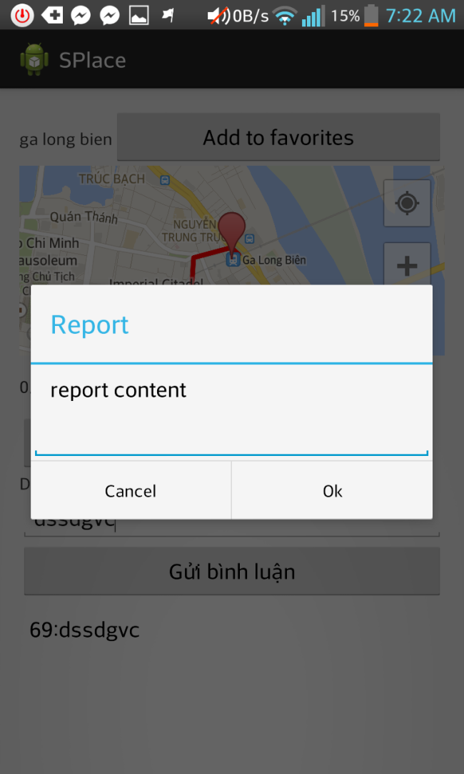

Figure 6-14: Report Comment

Click “Ok” after filling content to send report to server.

## Reference